SDP PROJECT

MOVIE MAKER’S TASK MANAGER

PROBLEM AND PURPOSE :

* The process of making a movie is a huge and vast venture that requires a humungous network and coordination amongst hundreds of people which if not properly handled can lead to an enormous capital loss .
* Hence there is a need for a system which helps to coordinate this multitude and keep track of the progress and various changes that take place during the making of a movie

GOAL :

* To make an efficient design for a software system which will conduct and minister the various processes that are involved in making of a commercial movie so that the various stakeholders can conveniently coordinate with each other and keep track of the progress .

METHODS :

* This software design has been made with the help of -
* CMAPs
* Class diagrams
* Sequence diagrams
* UseCase diagrams

Keeping the standard UML diagrams i.e Class diagrams and Sequence diagrams as the base the CMAPs were constructed which help to understand the flow , connections , change of variables and these can also be used to analyse different scenarios .

* The diagrams and cmap were made keeping in mind the ease of implementation for the programmer .
* Sequence diagrams help us understand the proper flow of events i.e. the sequence in which function calls will occur .
* Class diagrams will help us understand the attributes (i.e the variables ) and the methods that each class will have .

Class diagrams :

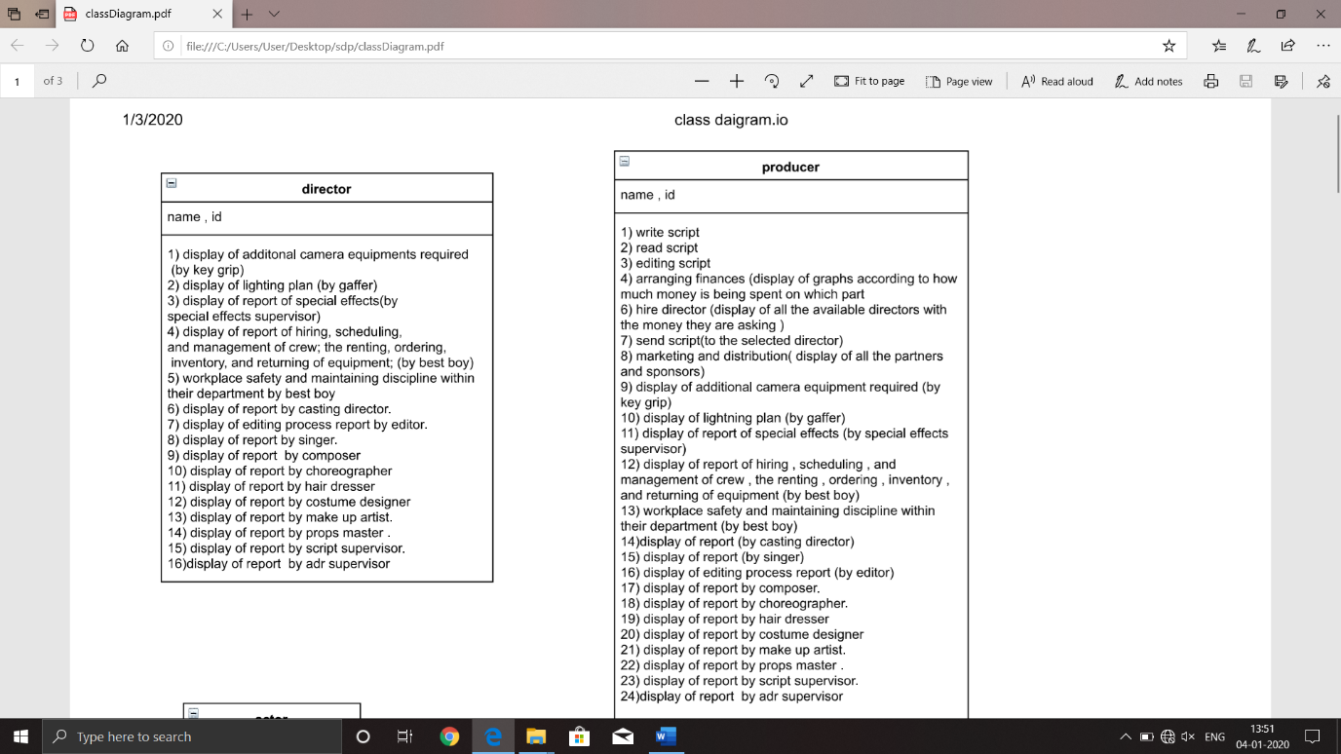

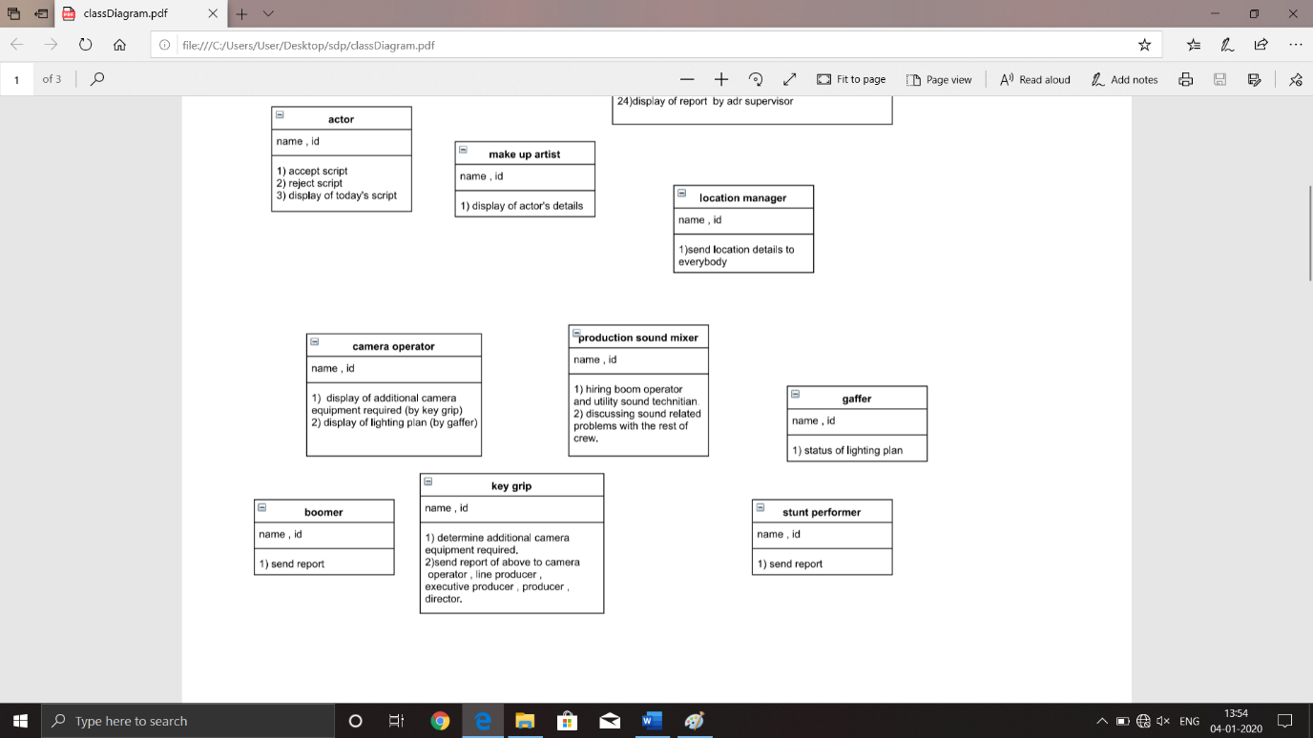

Case diagrams:

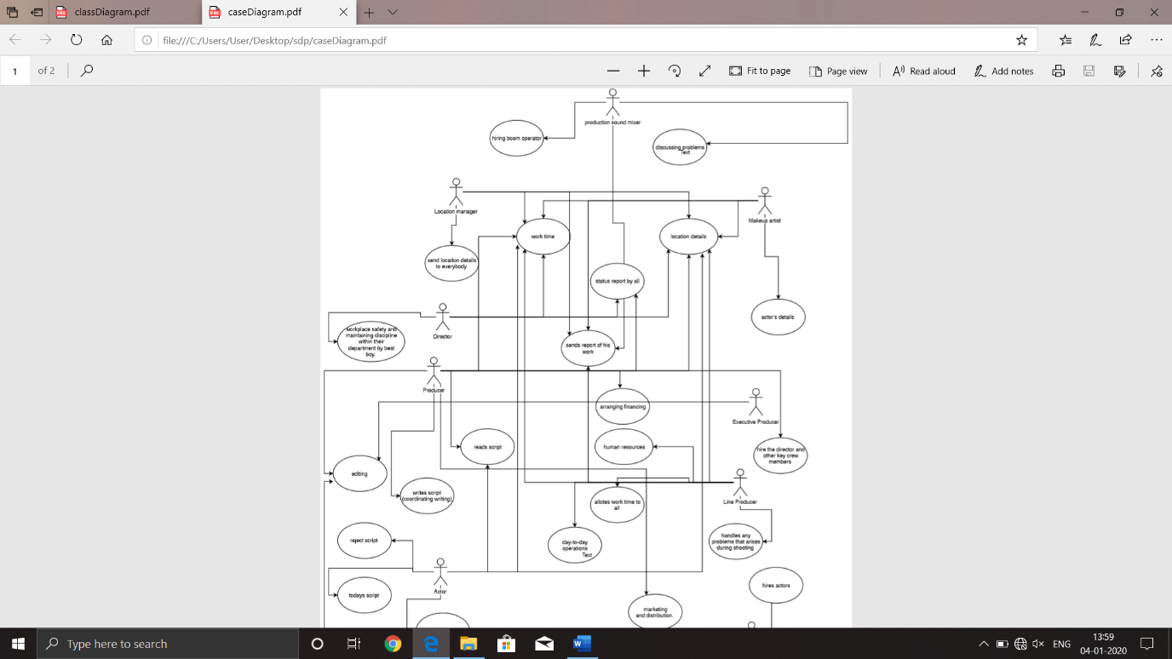

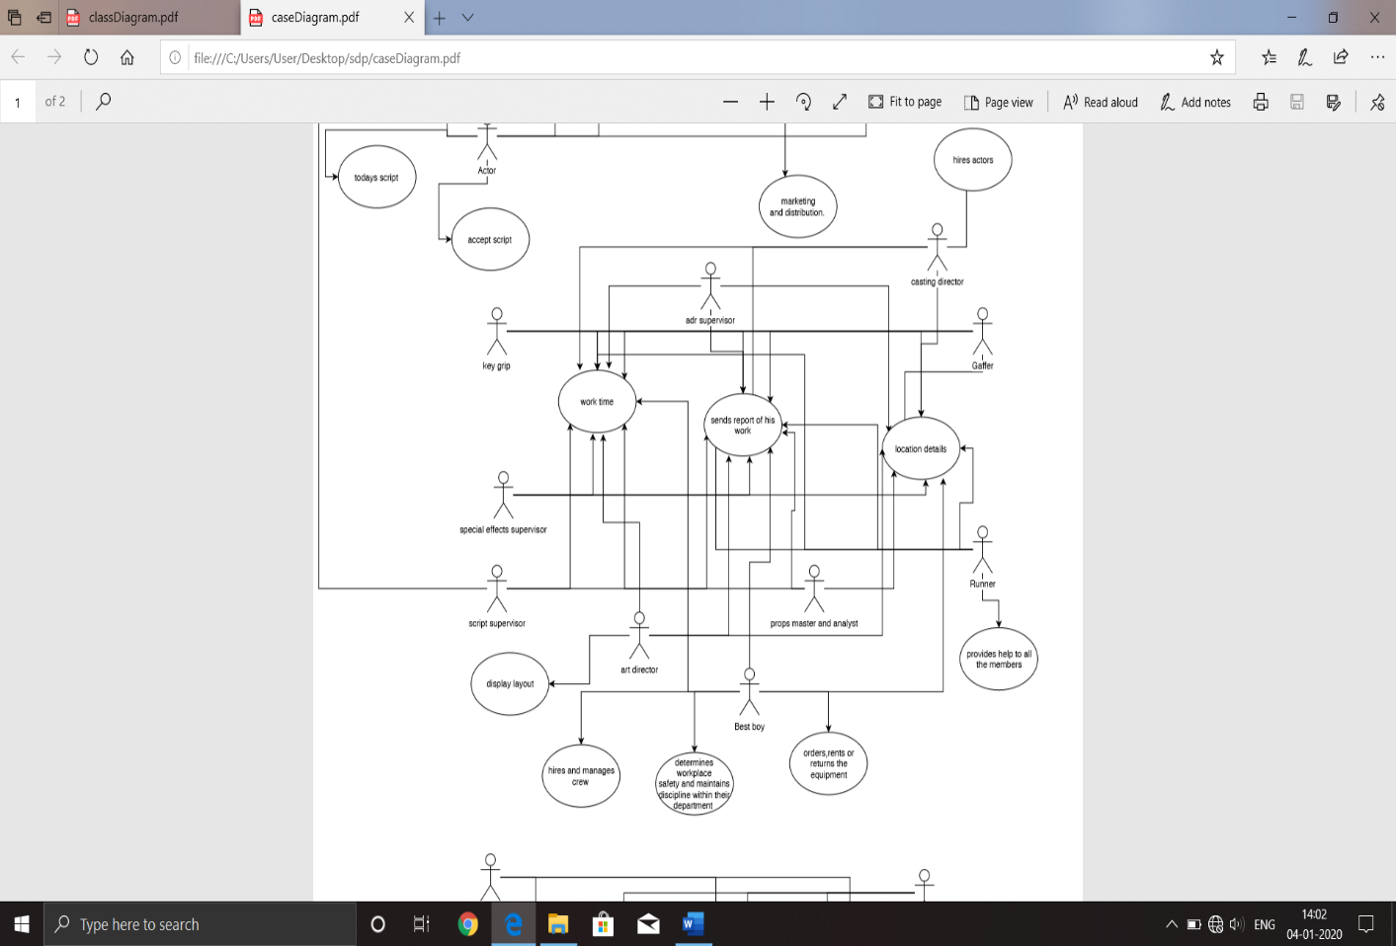

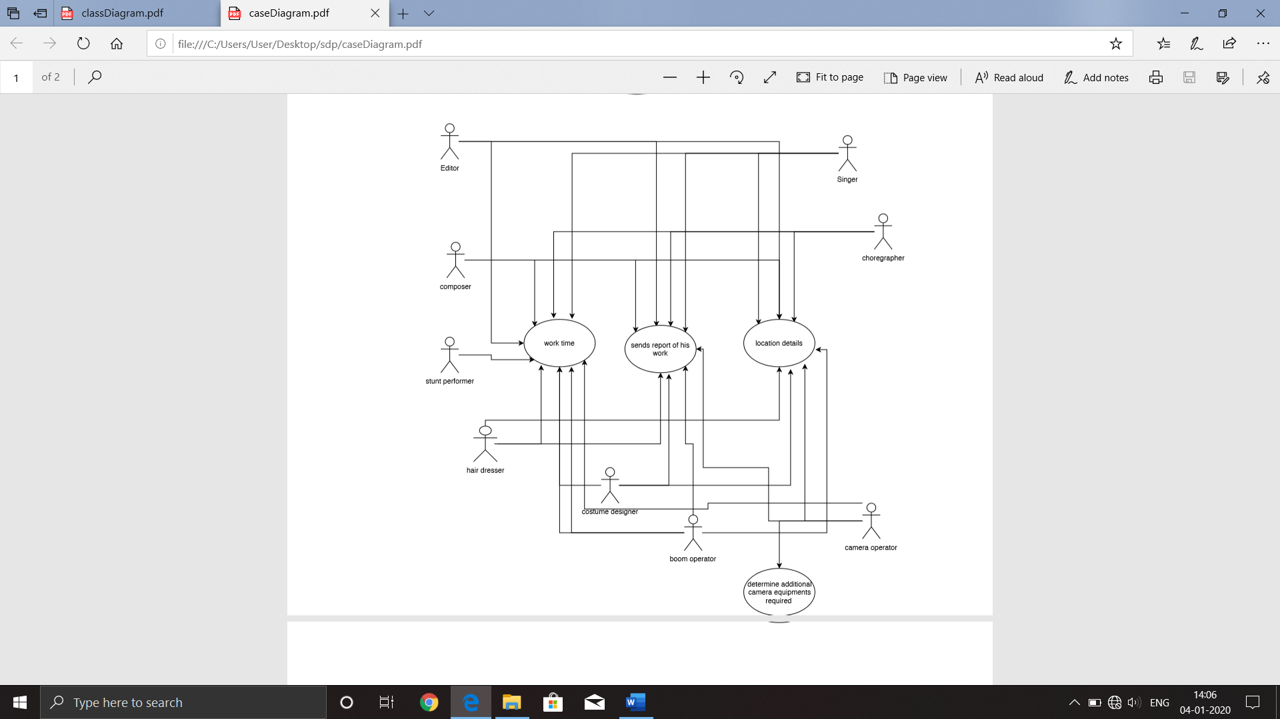

Sequence diagrams :

Actor :

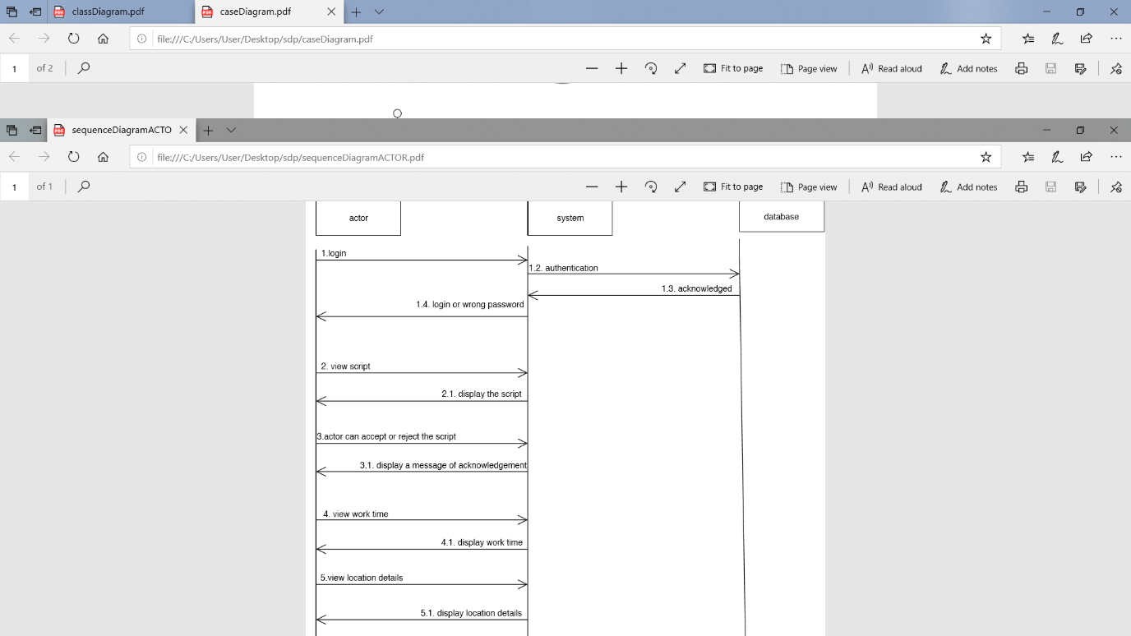

Executive Producer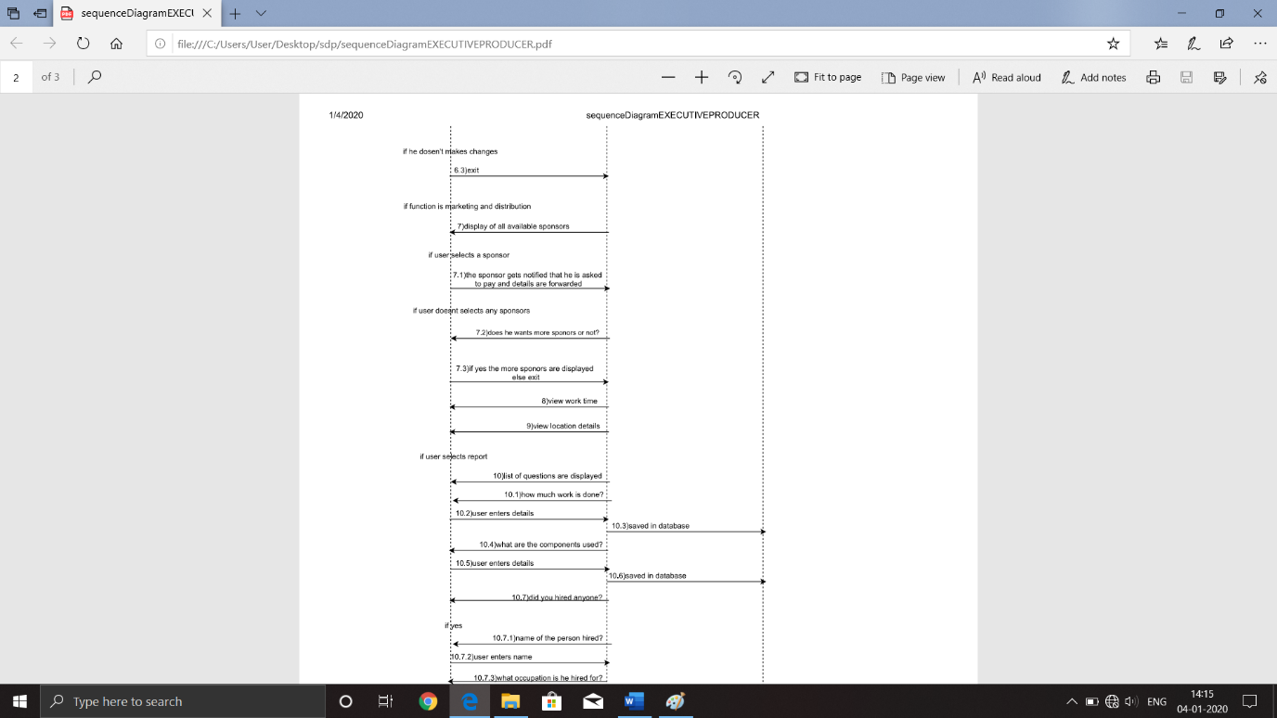

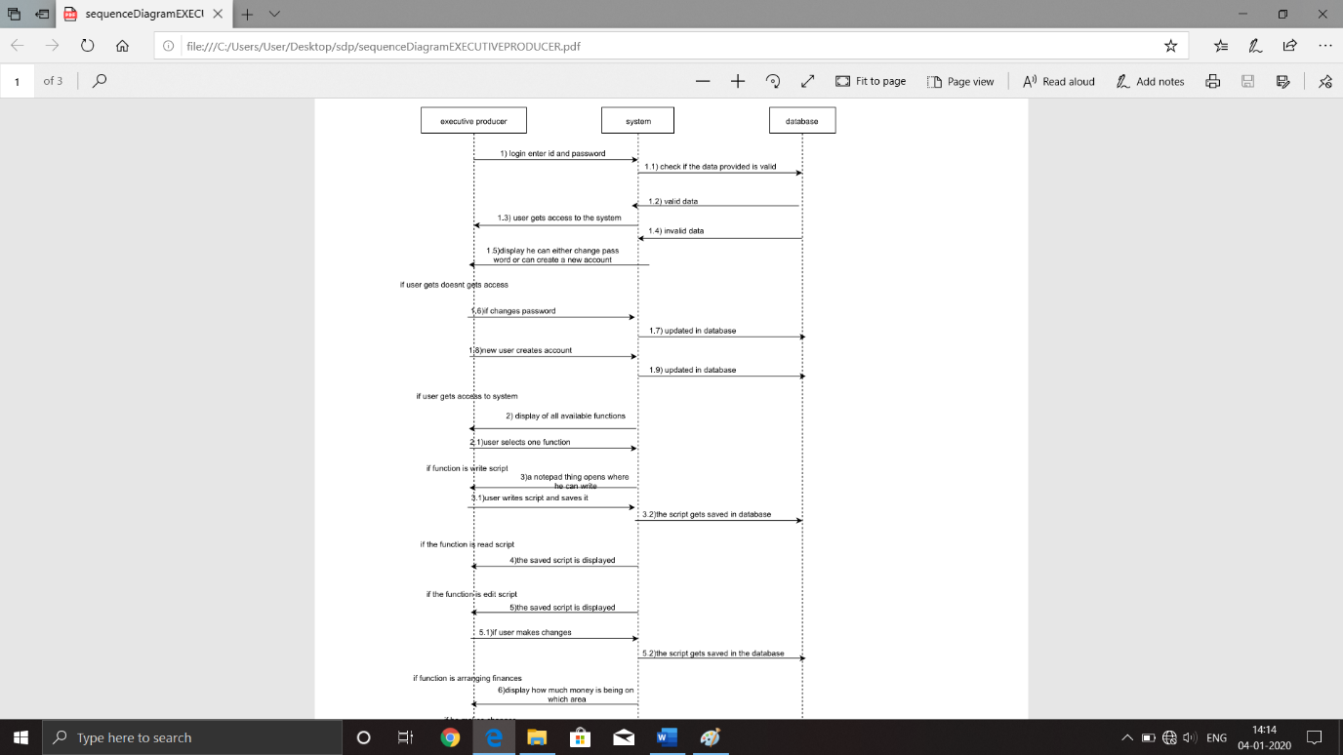

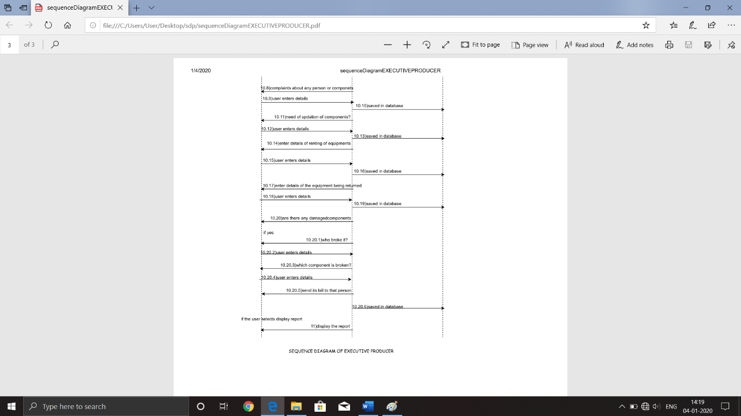

DIRECTOR:

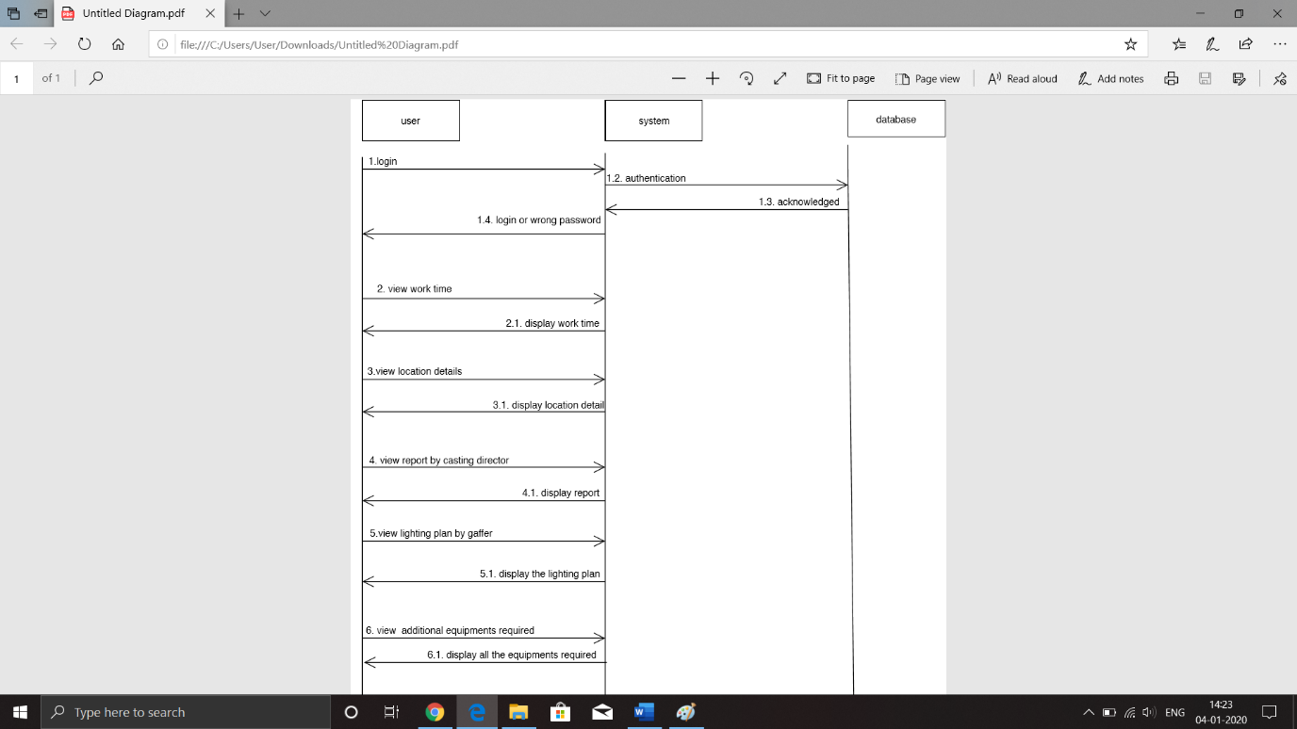

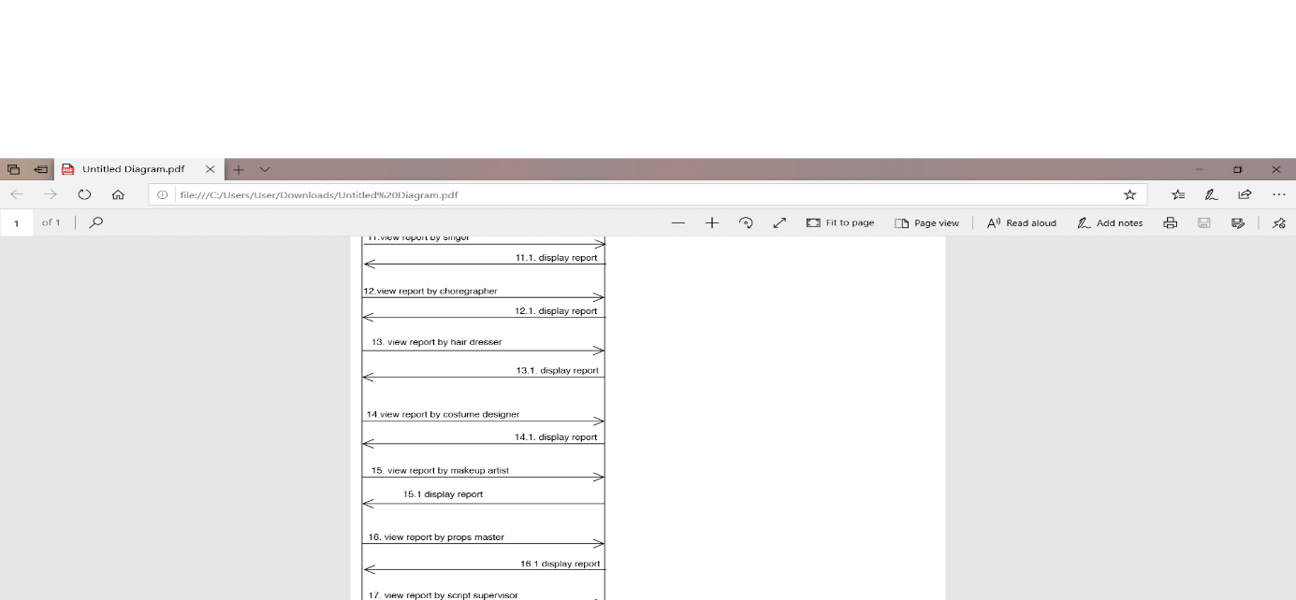

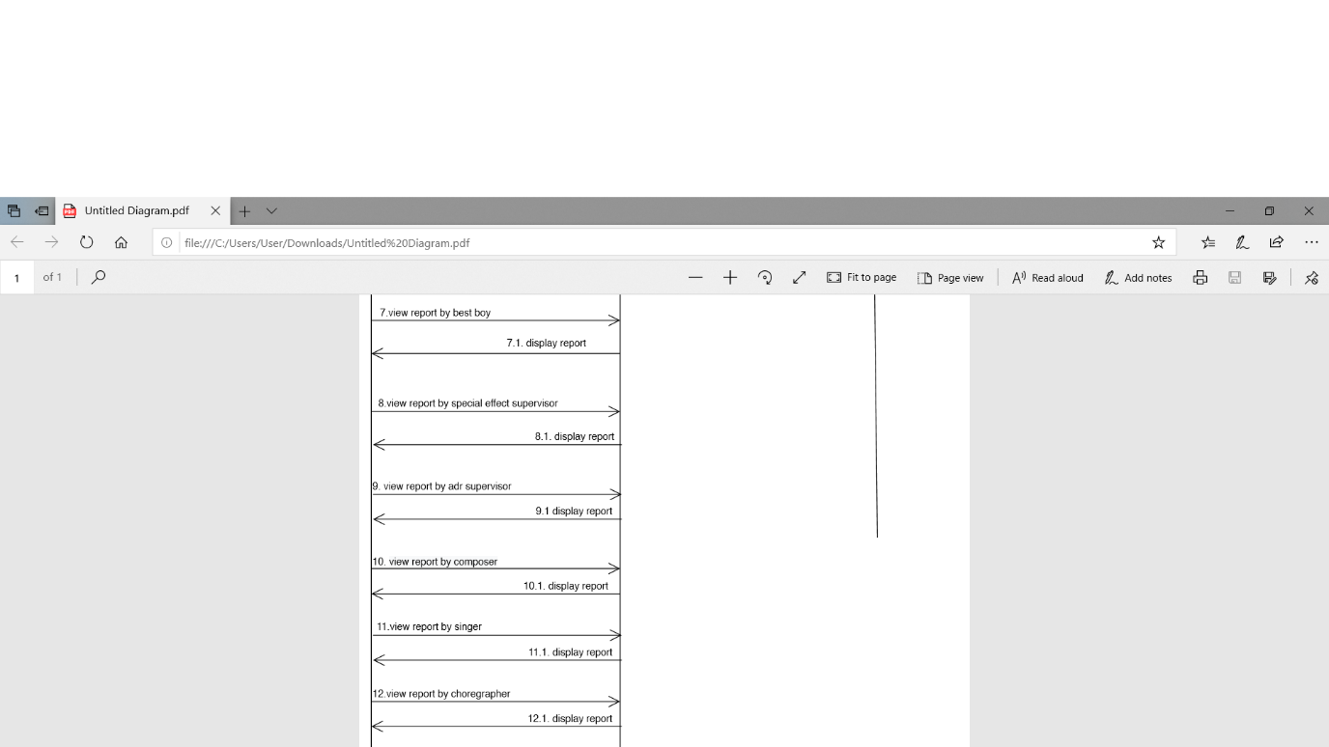

LINE PRODUCER:

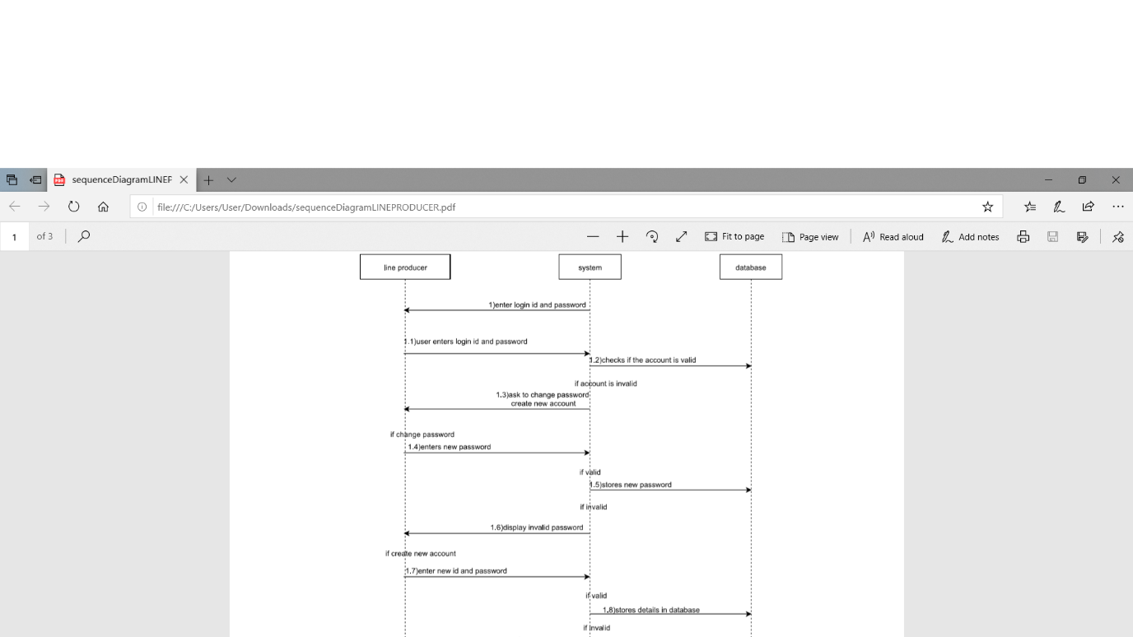

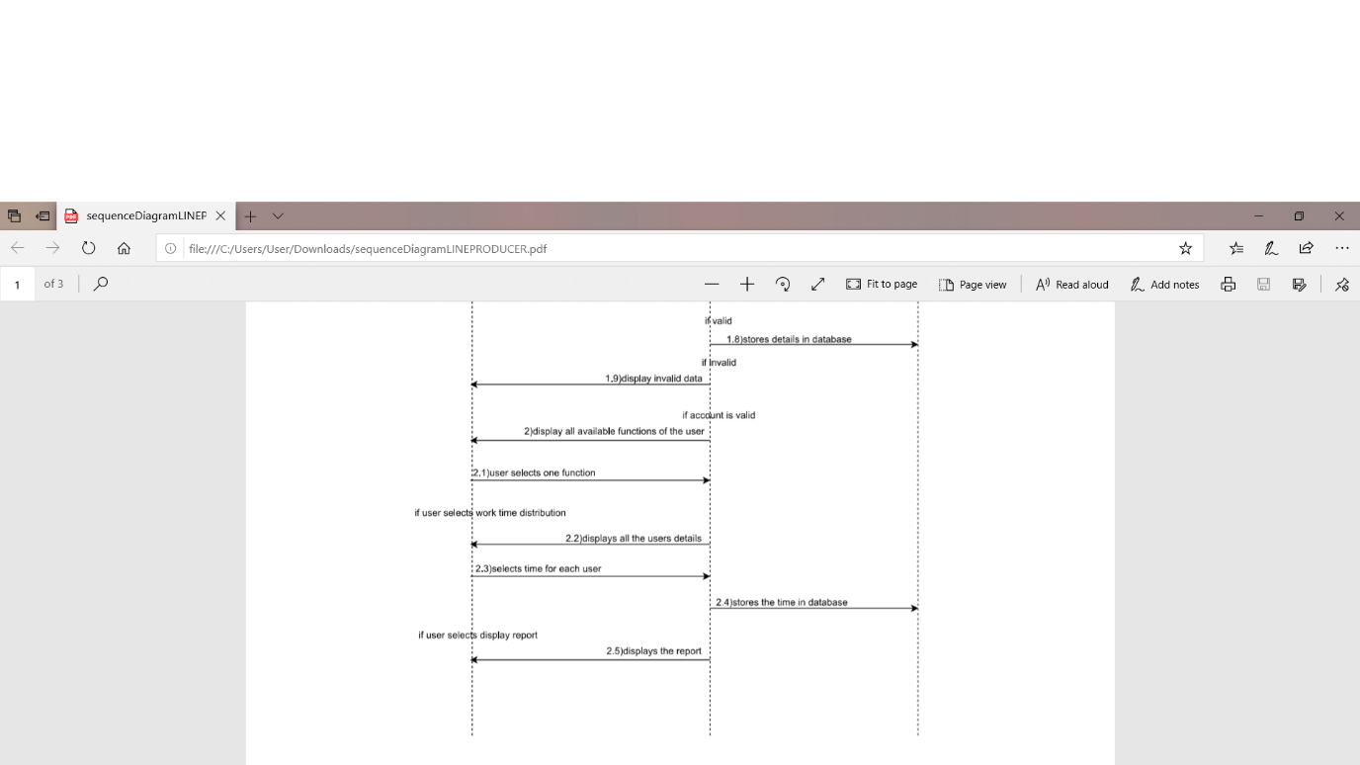

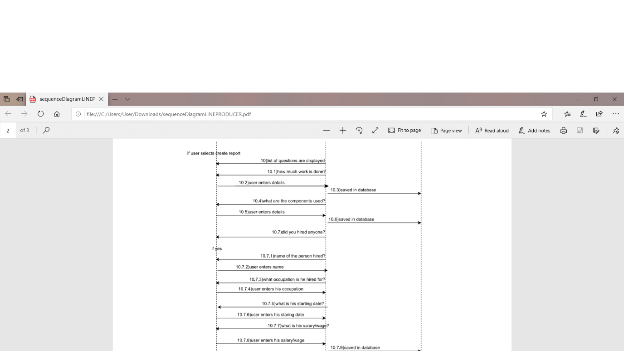

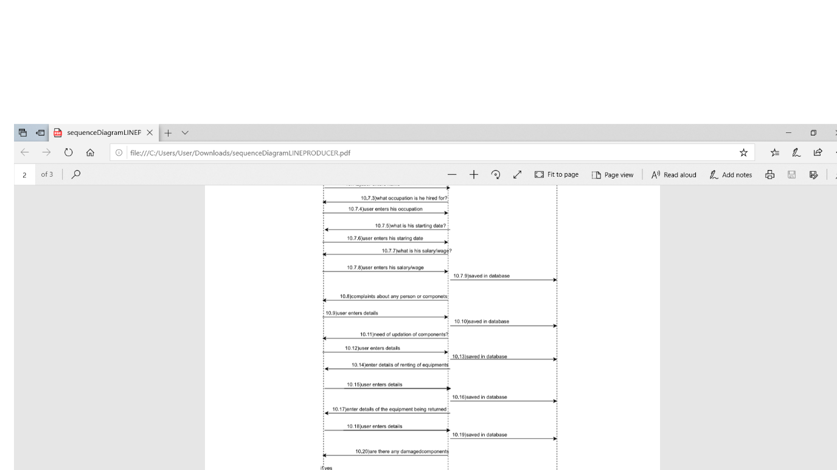

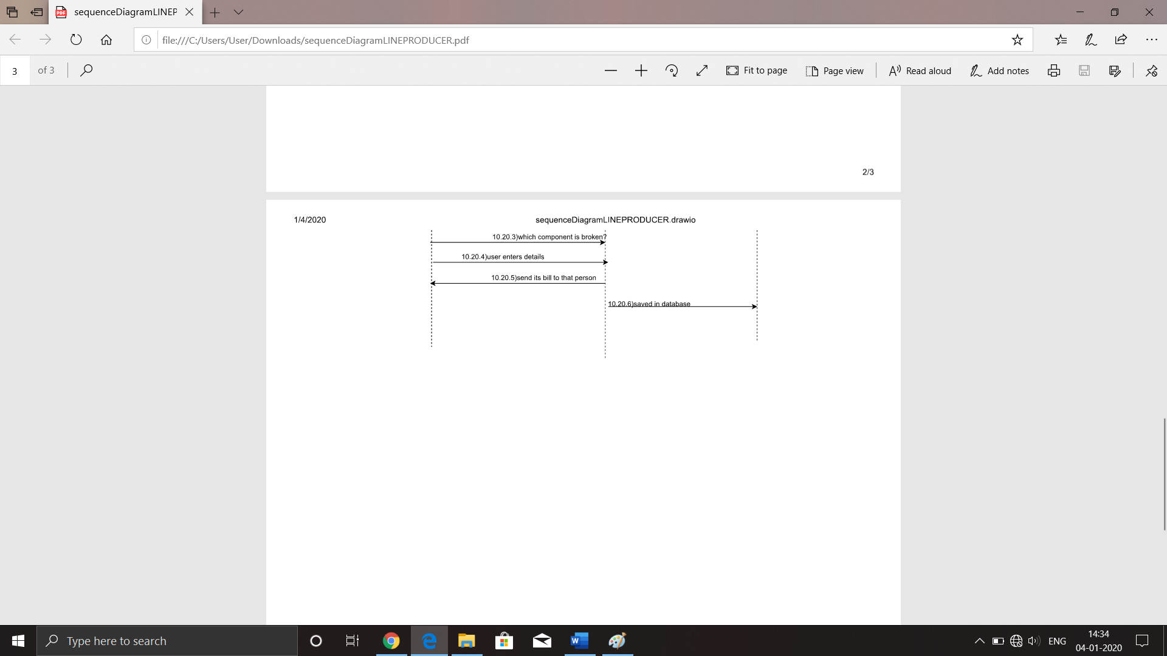

LOCATION MANAGER :

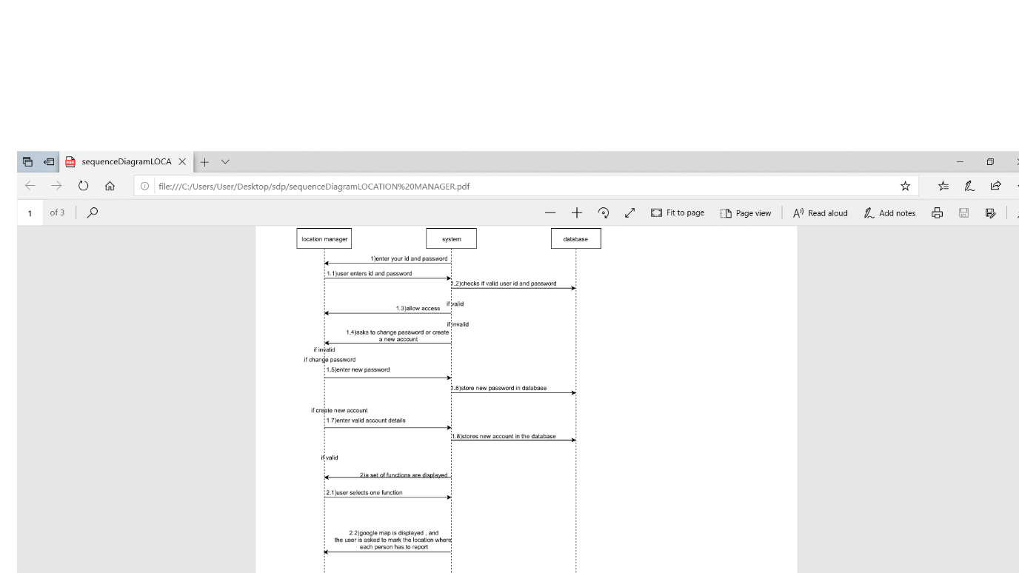  
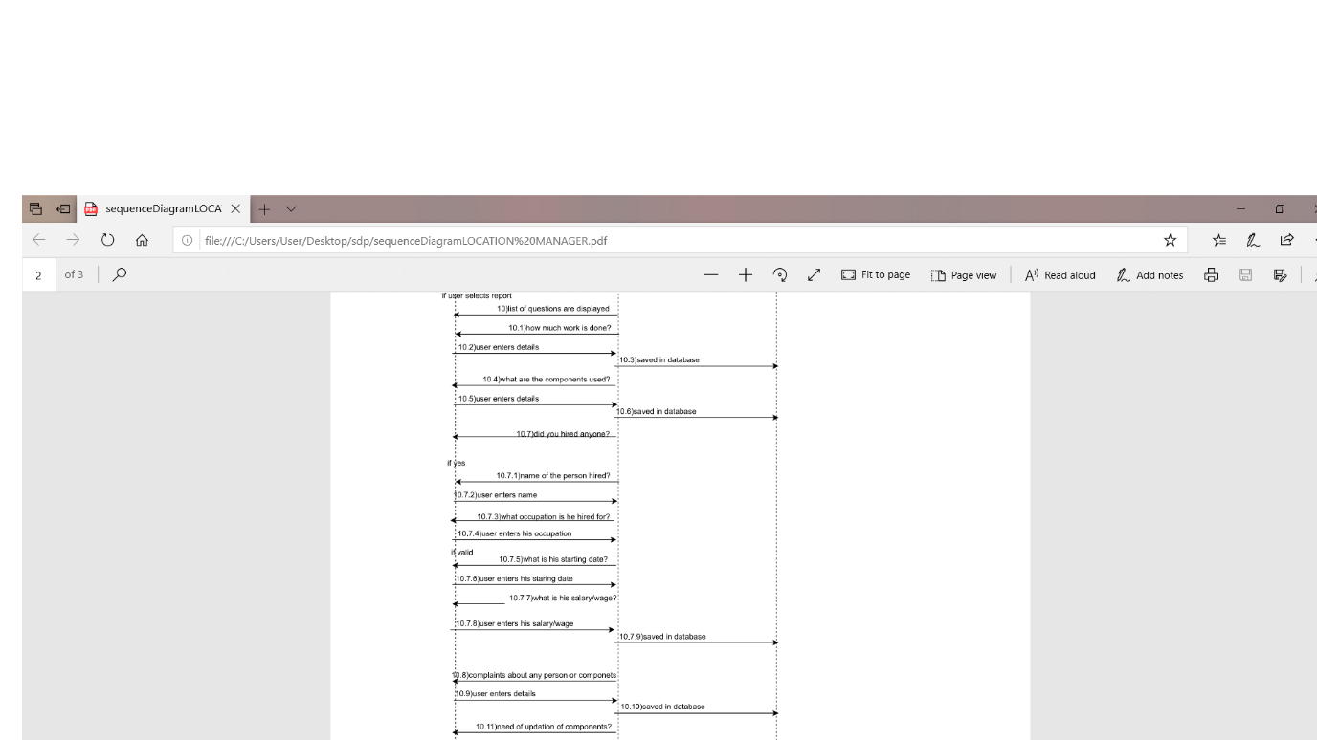

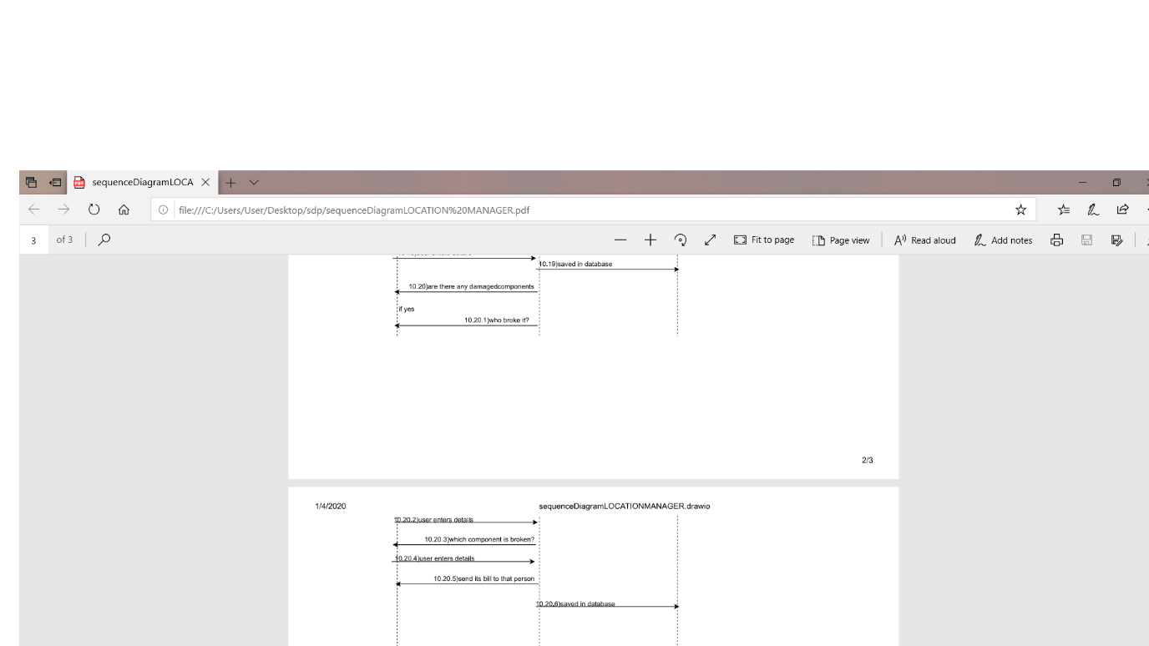

CAMERAOPERATOR :

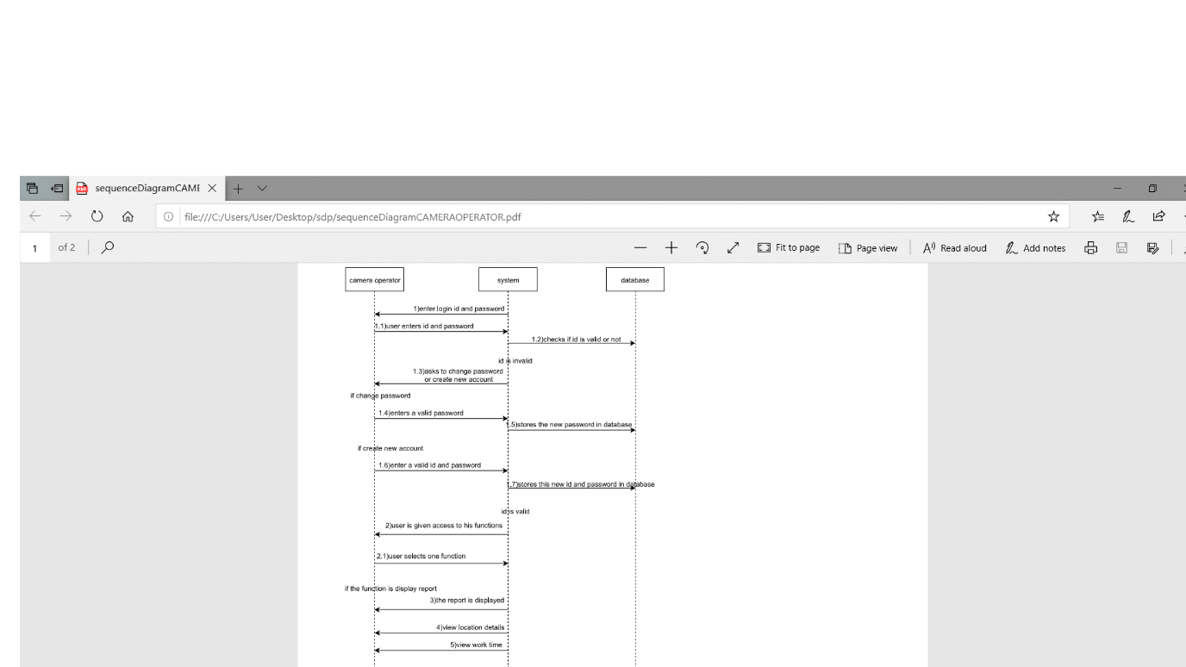

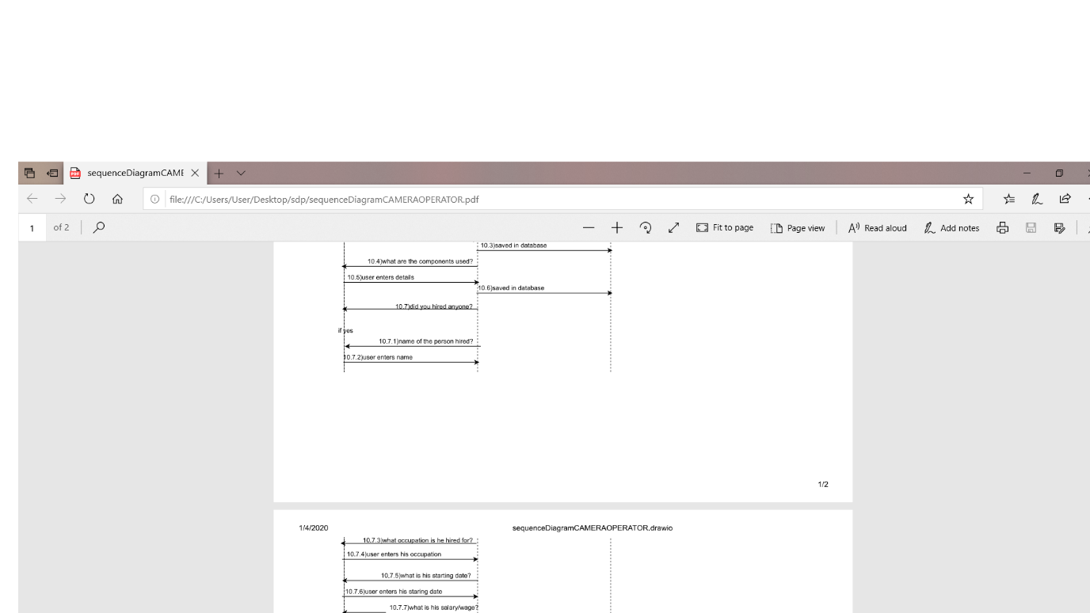

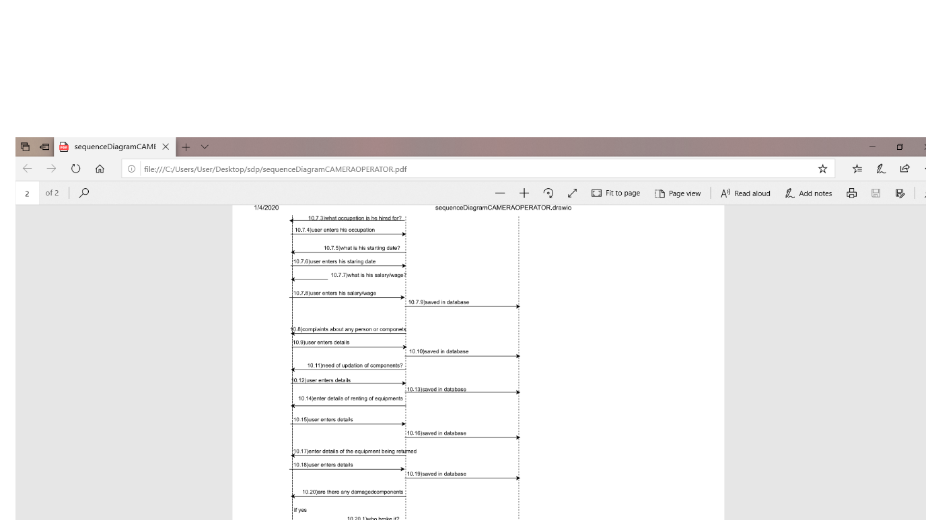

BOOMOPERATOR :

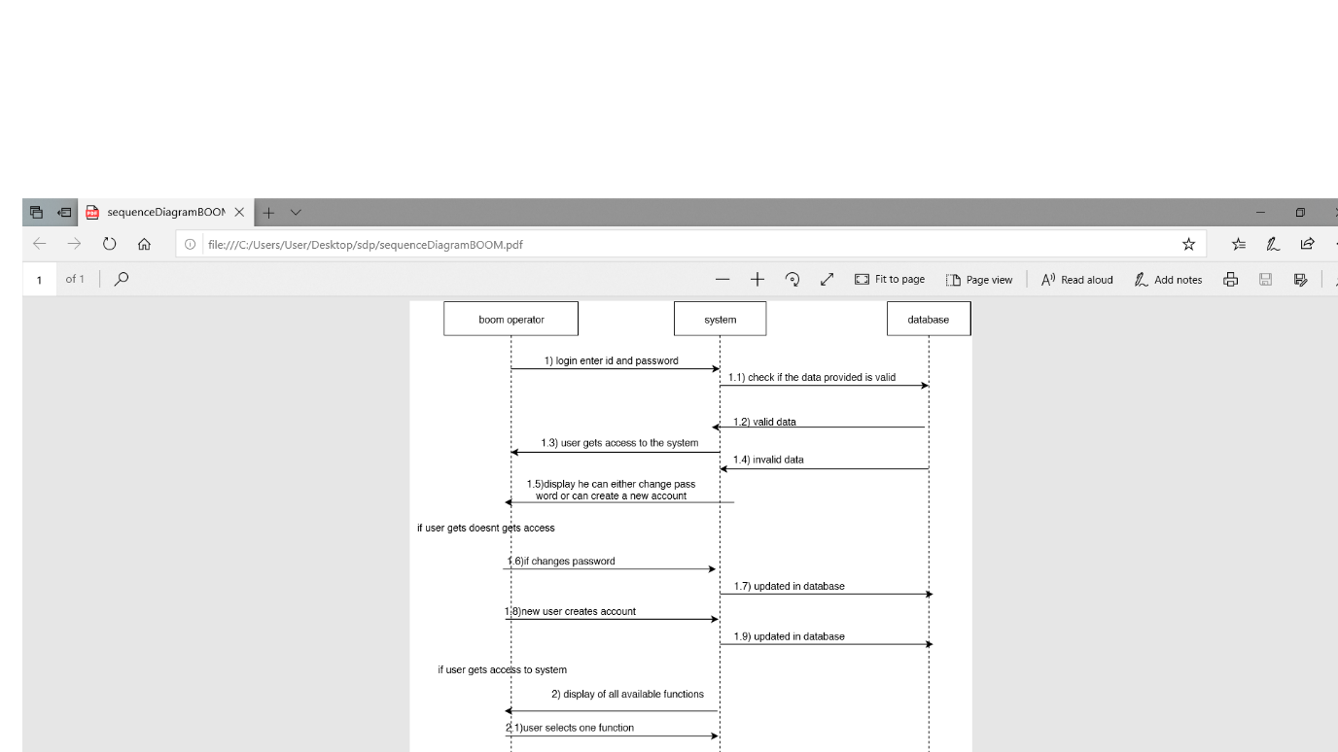

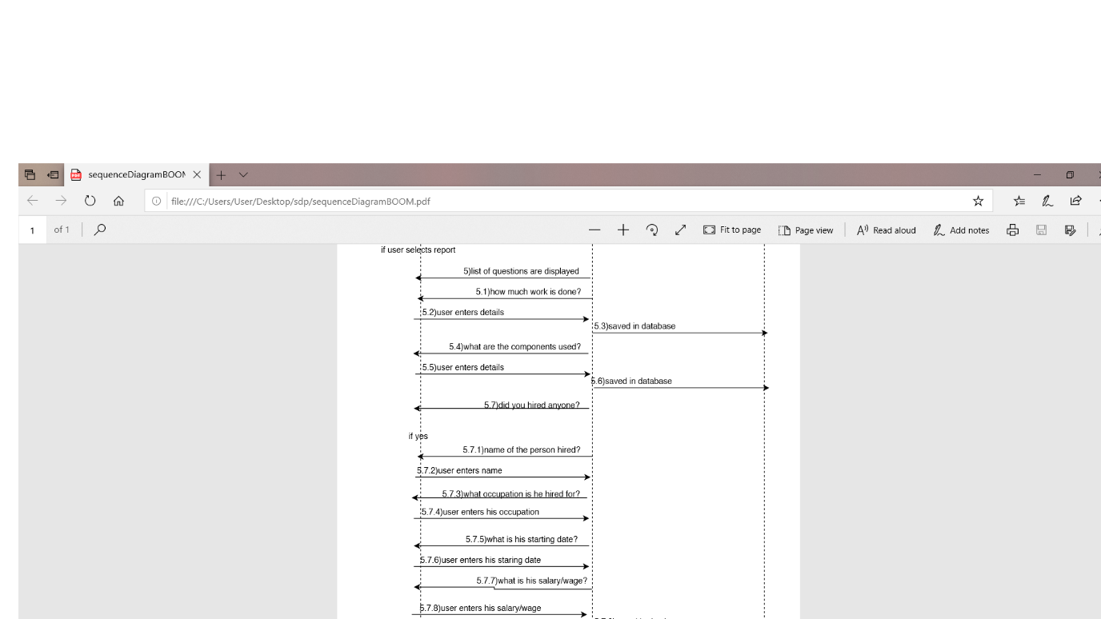

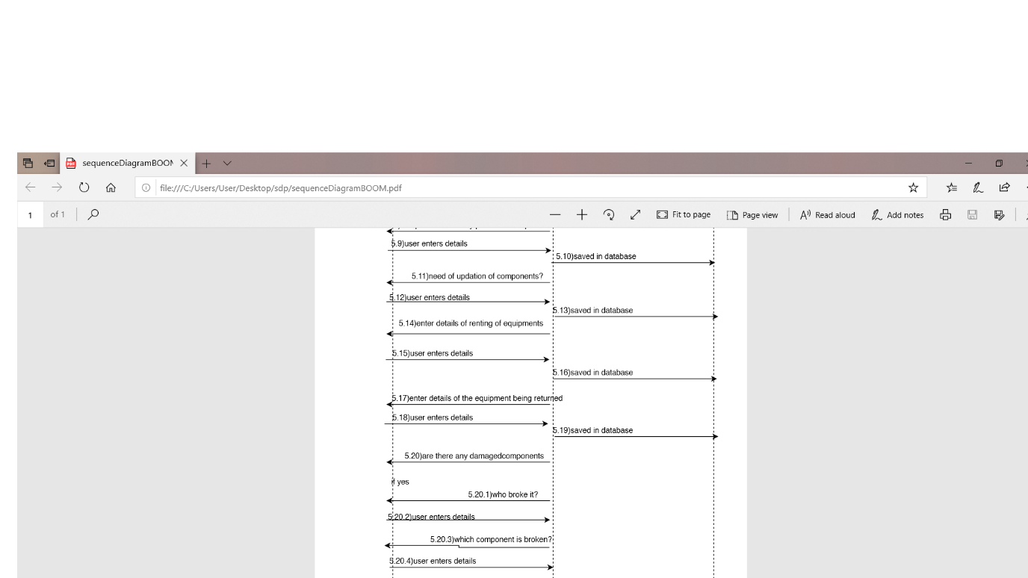

COSTUME DESIGNER:

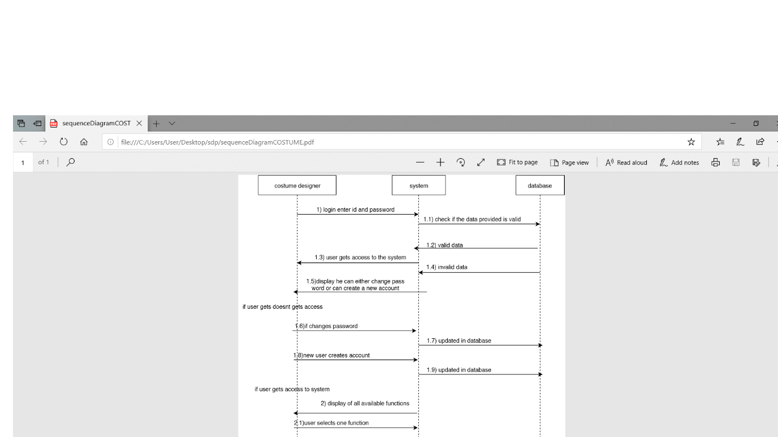

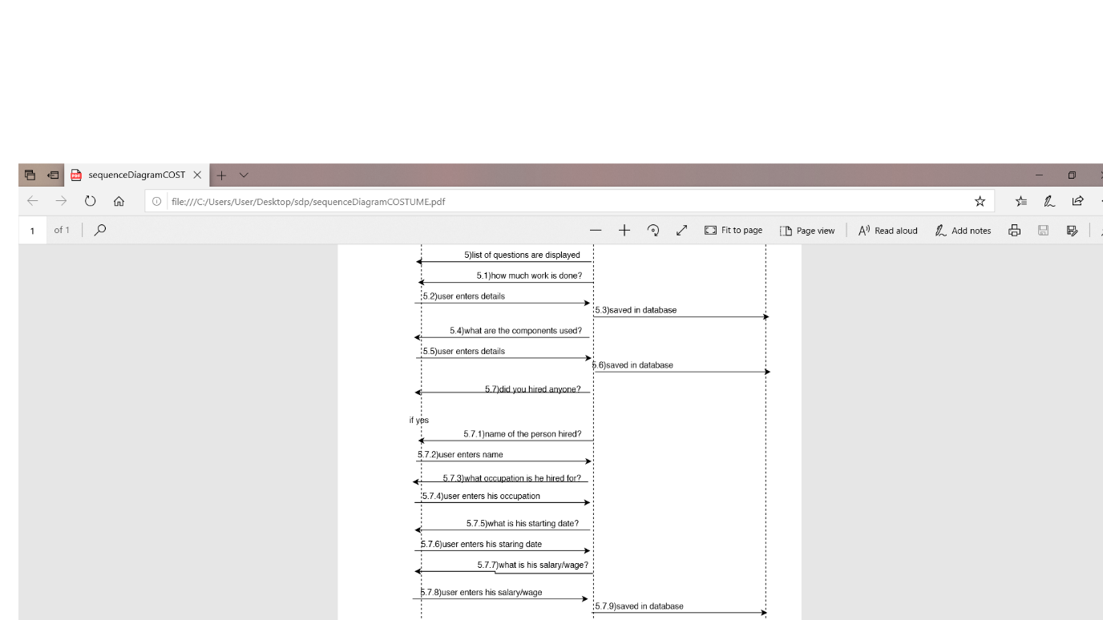

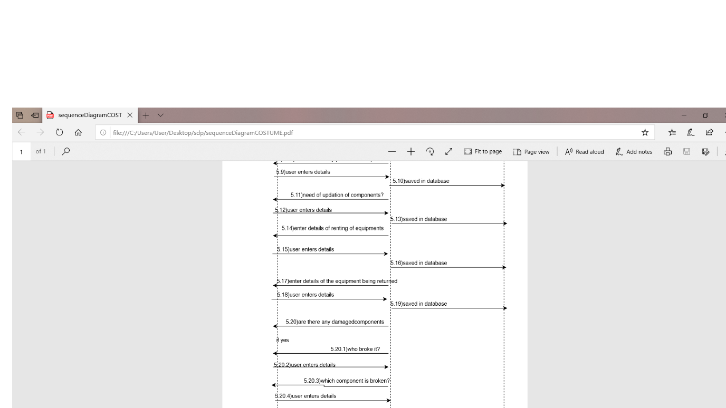

GAFFER:

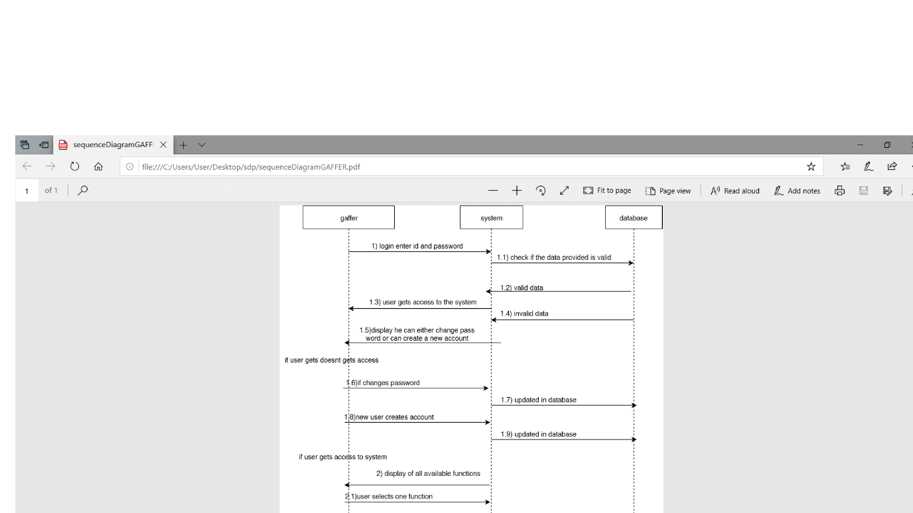

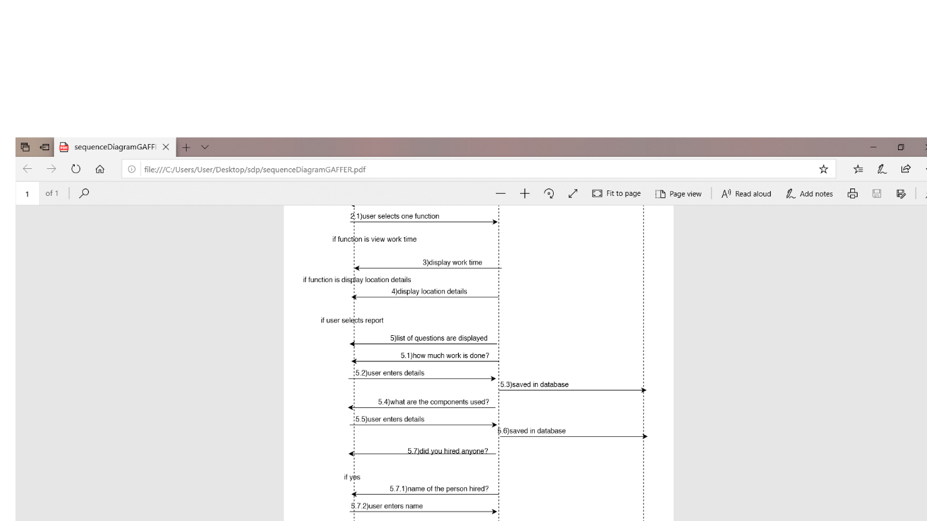

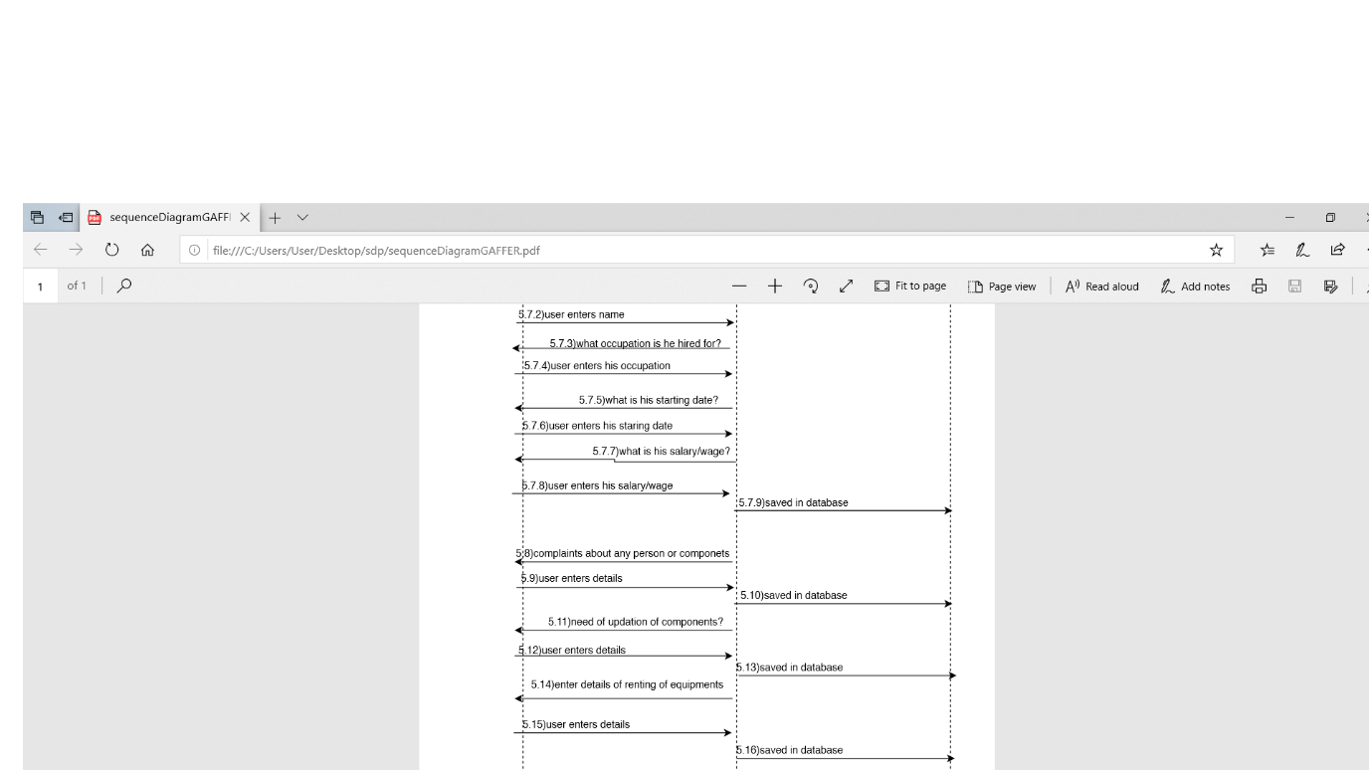

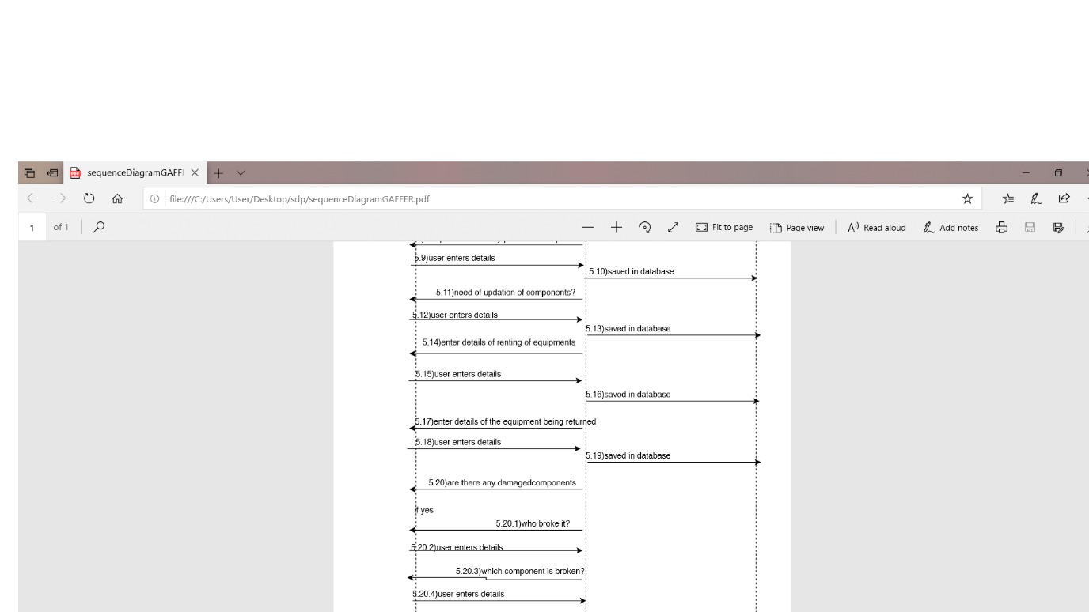

HAIR DRESSER:

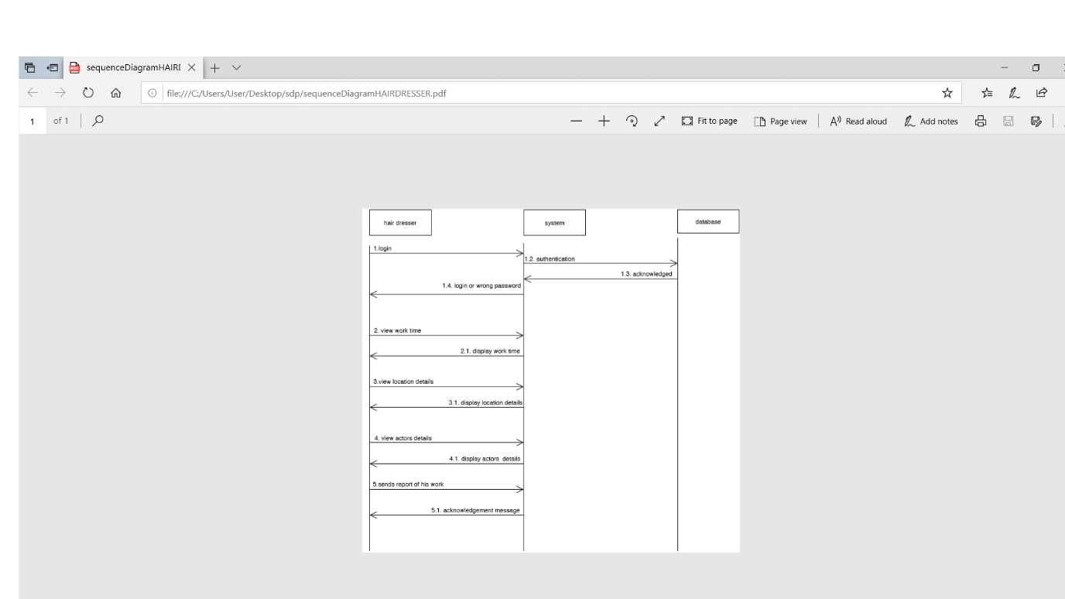

KEY GRIPPER:

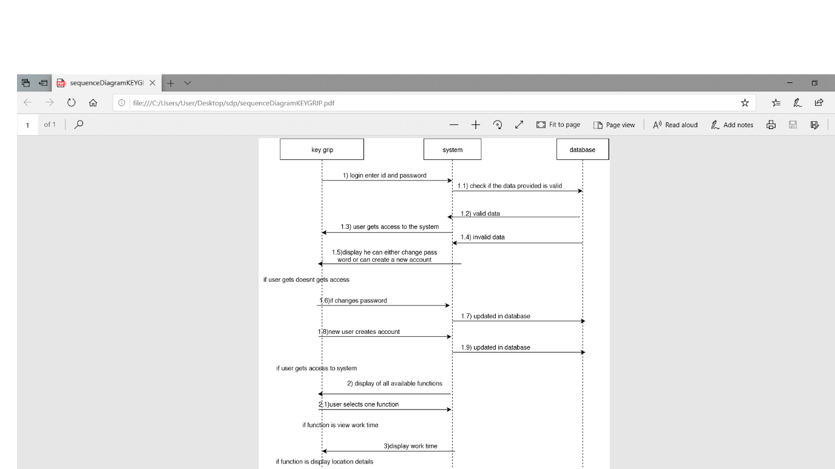

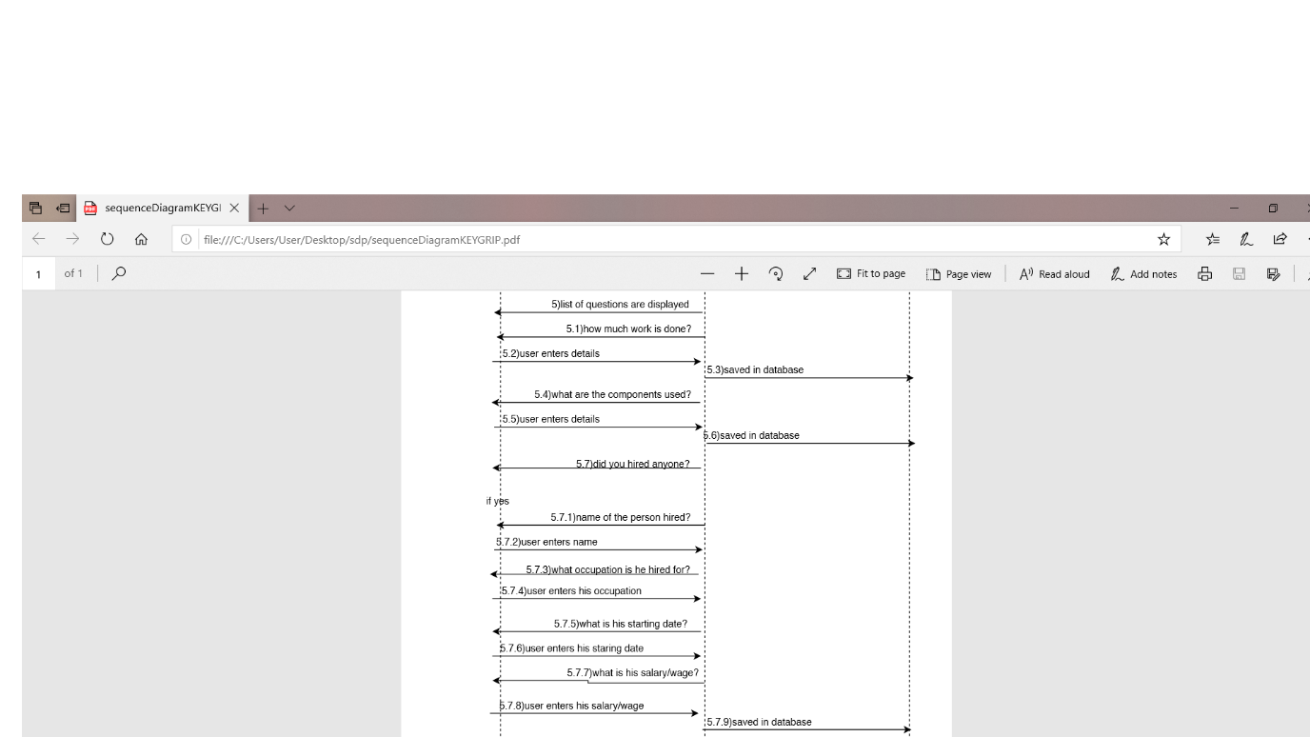

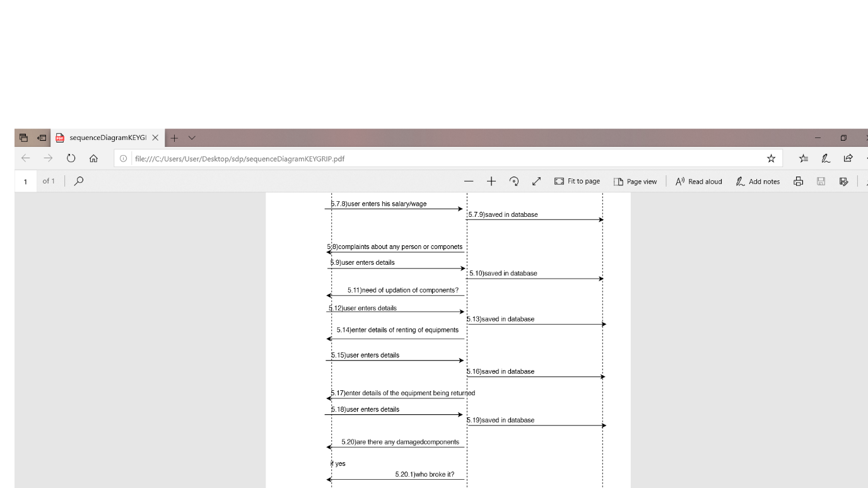

MAKEUP ARTIST:

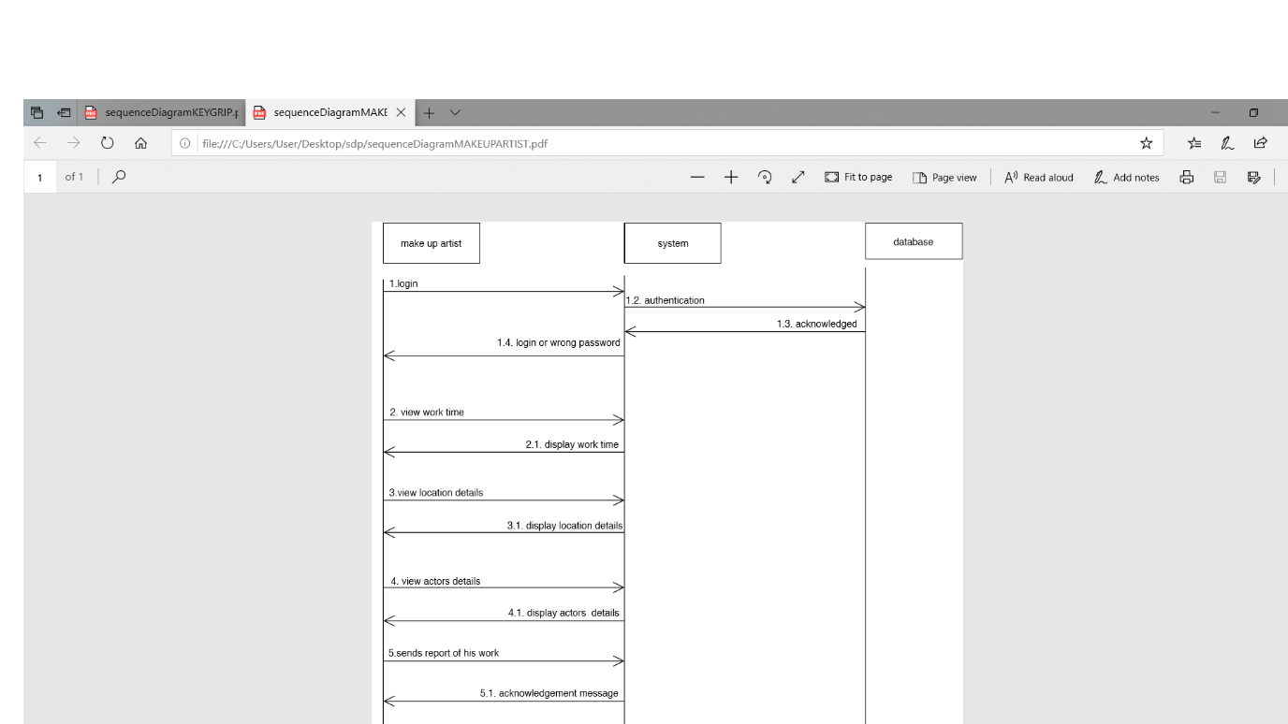

PROPS MASTER AND ANALYST:

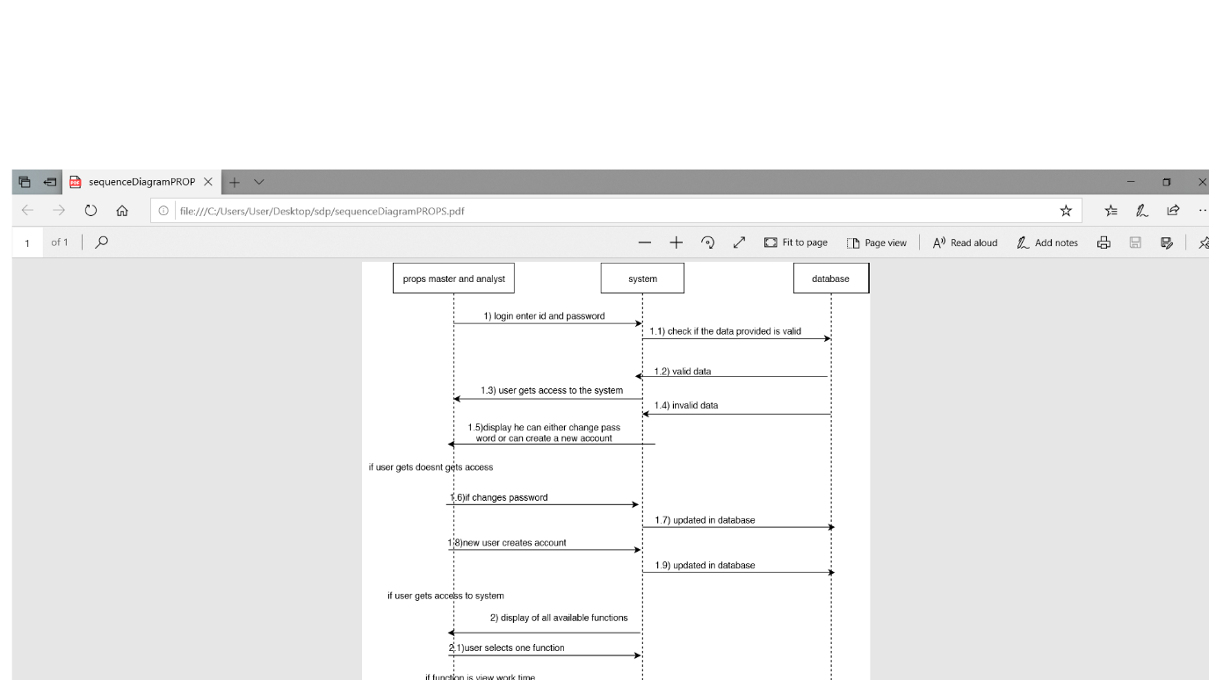

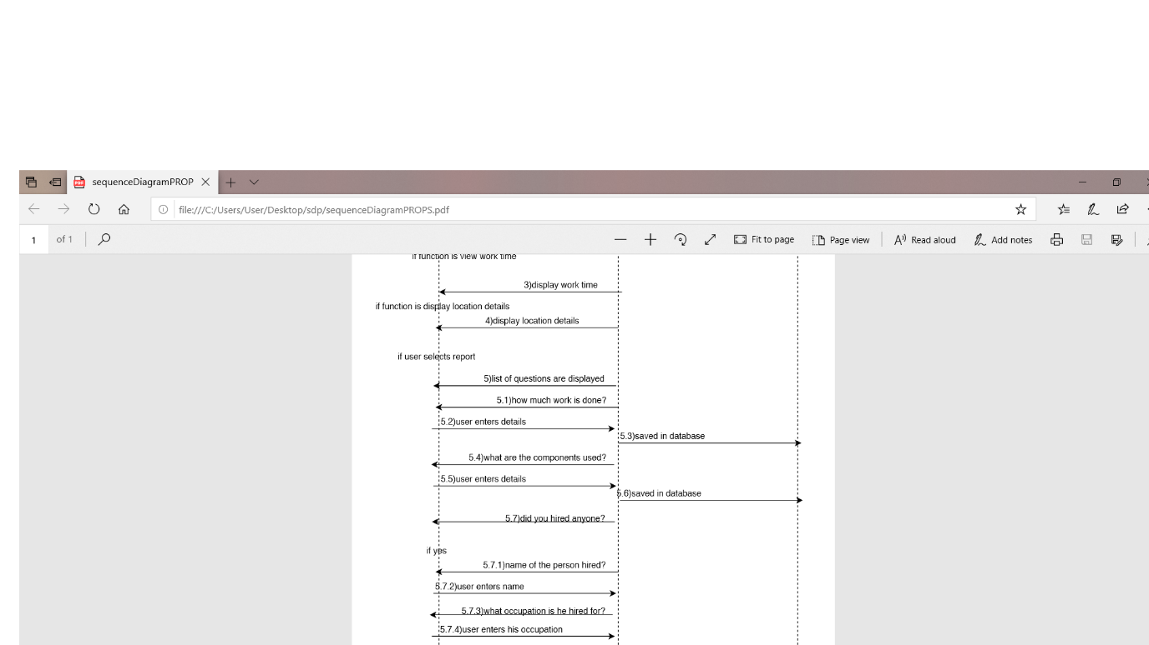

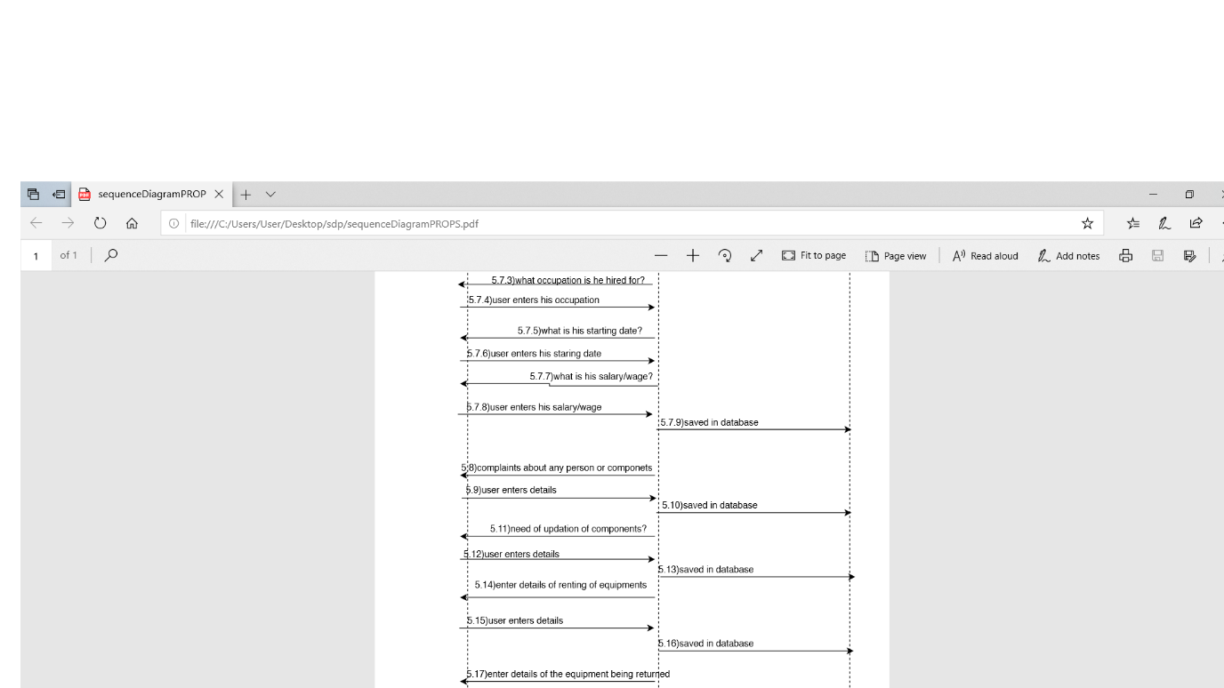

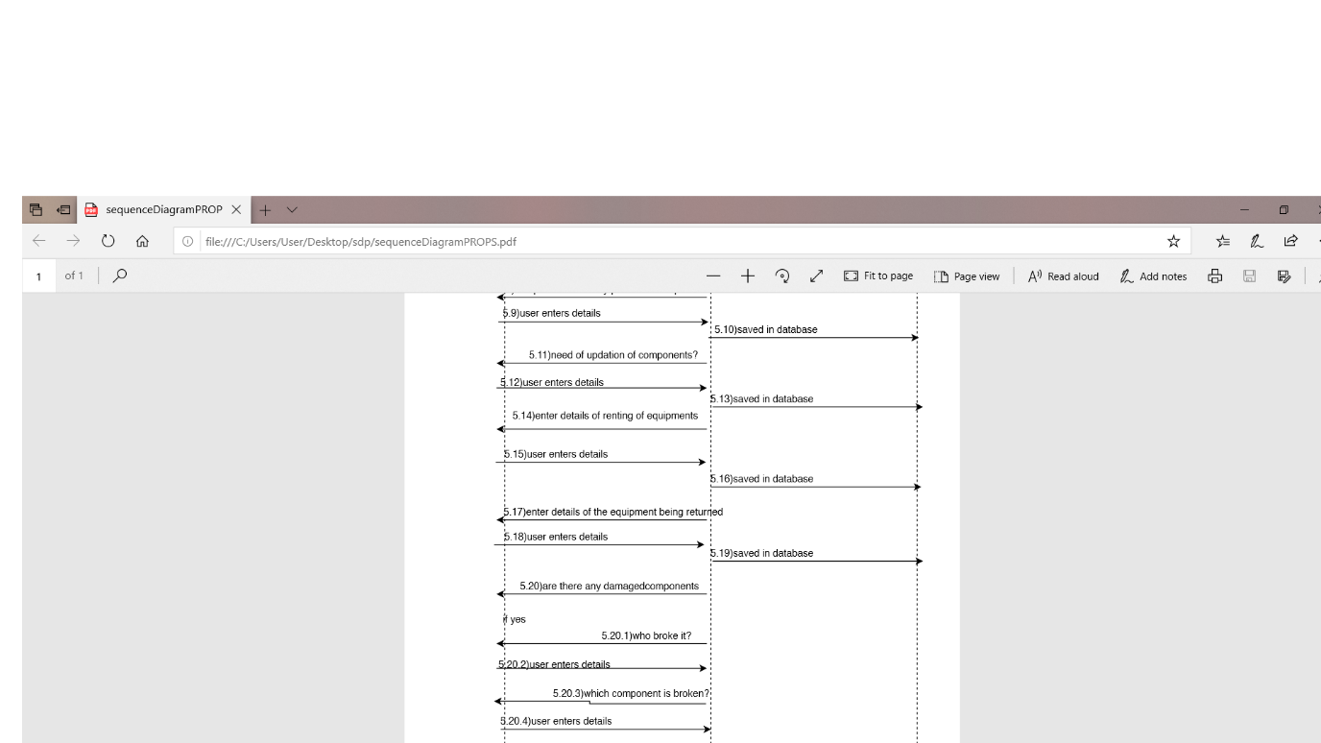

CMAPS:

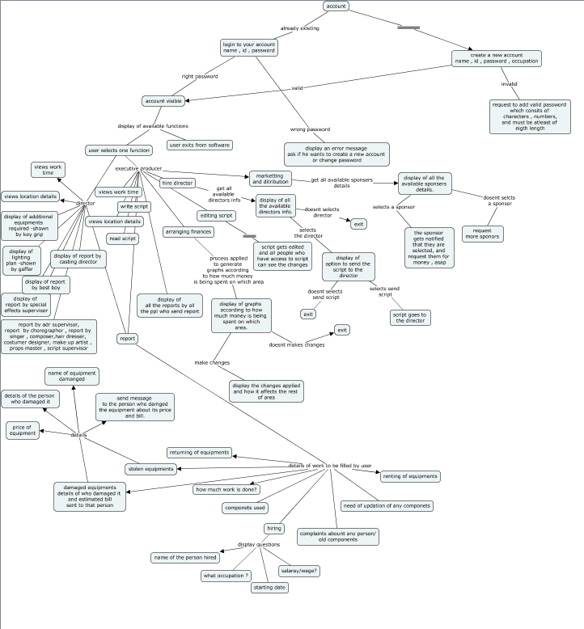

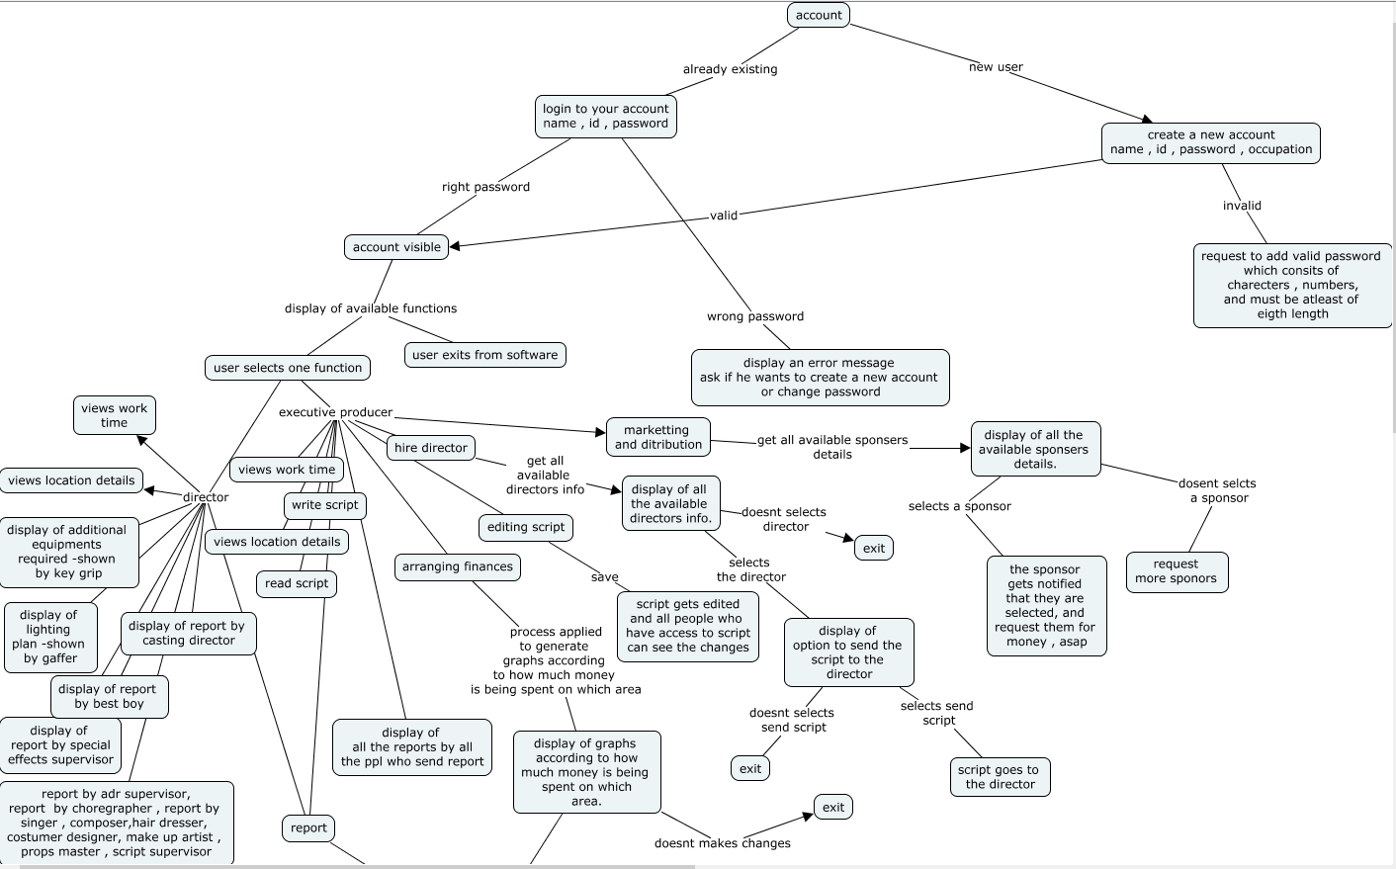

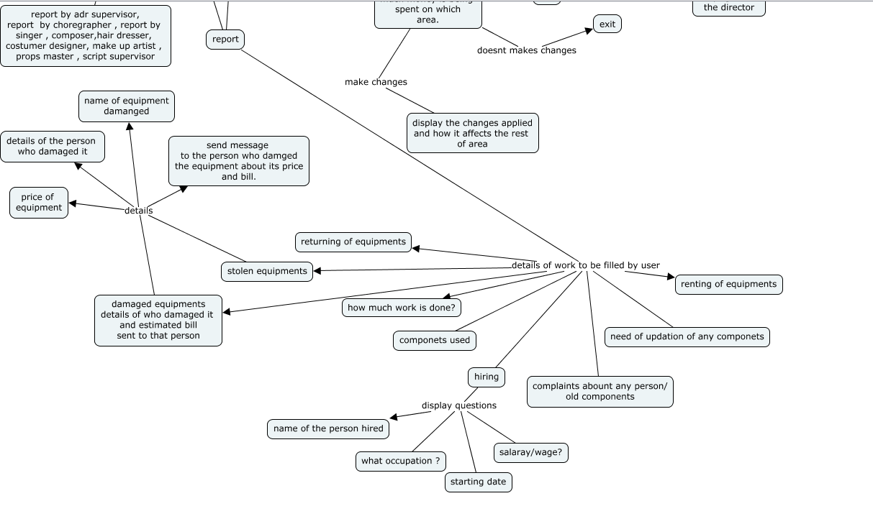

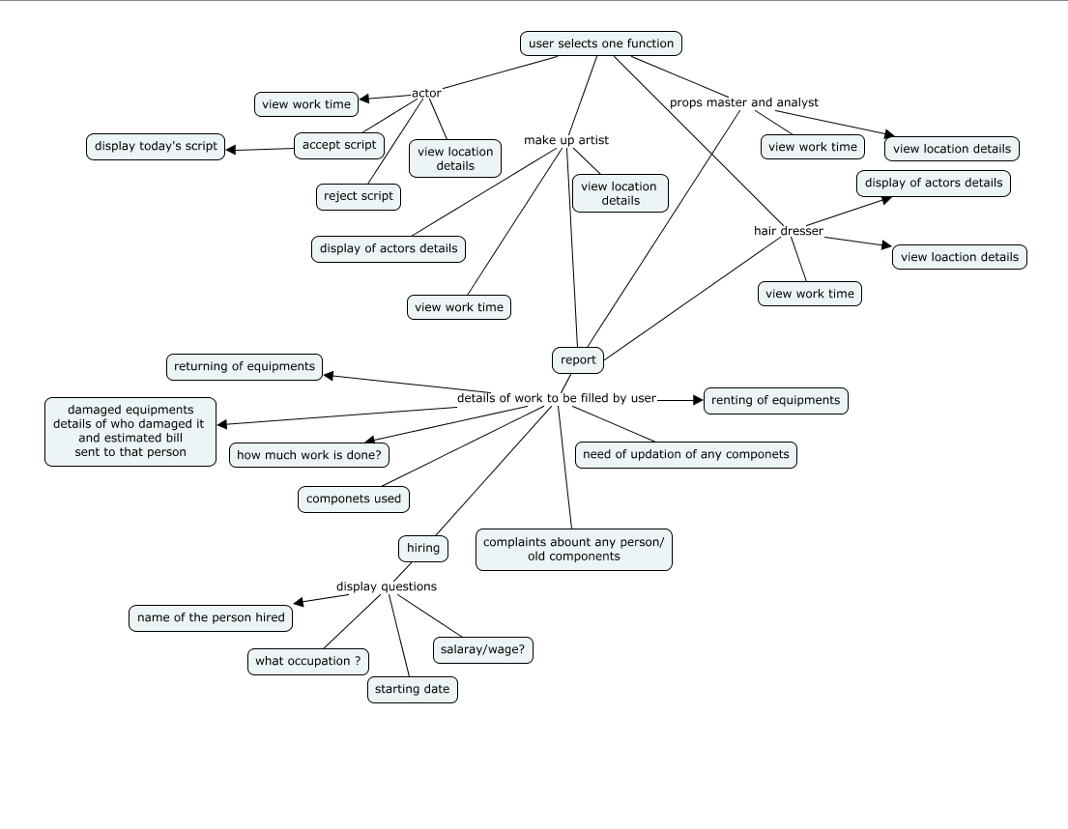

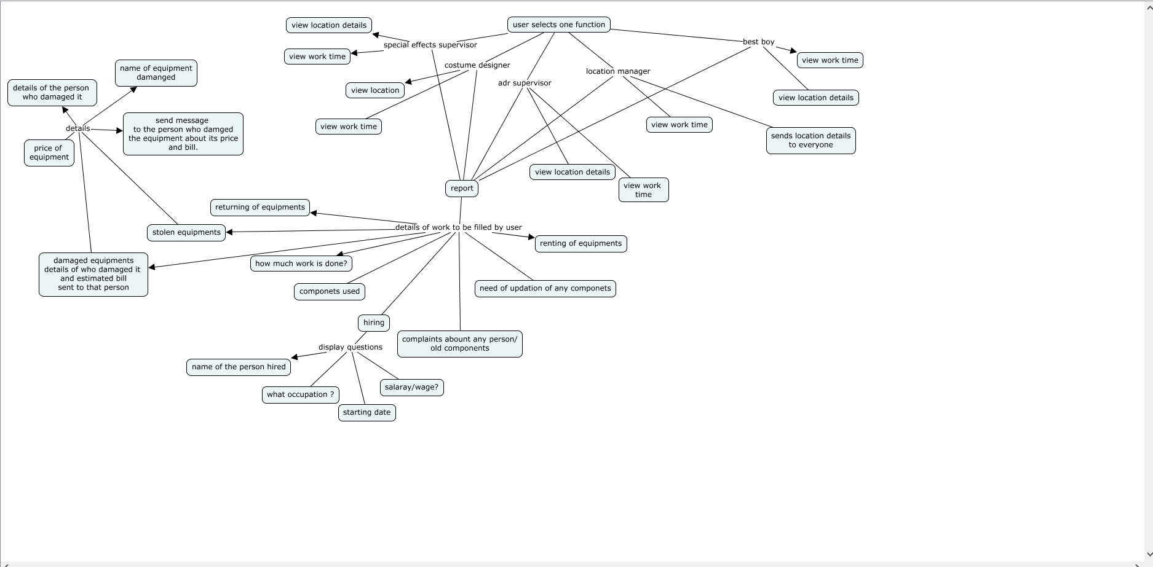

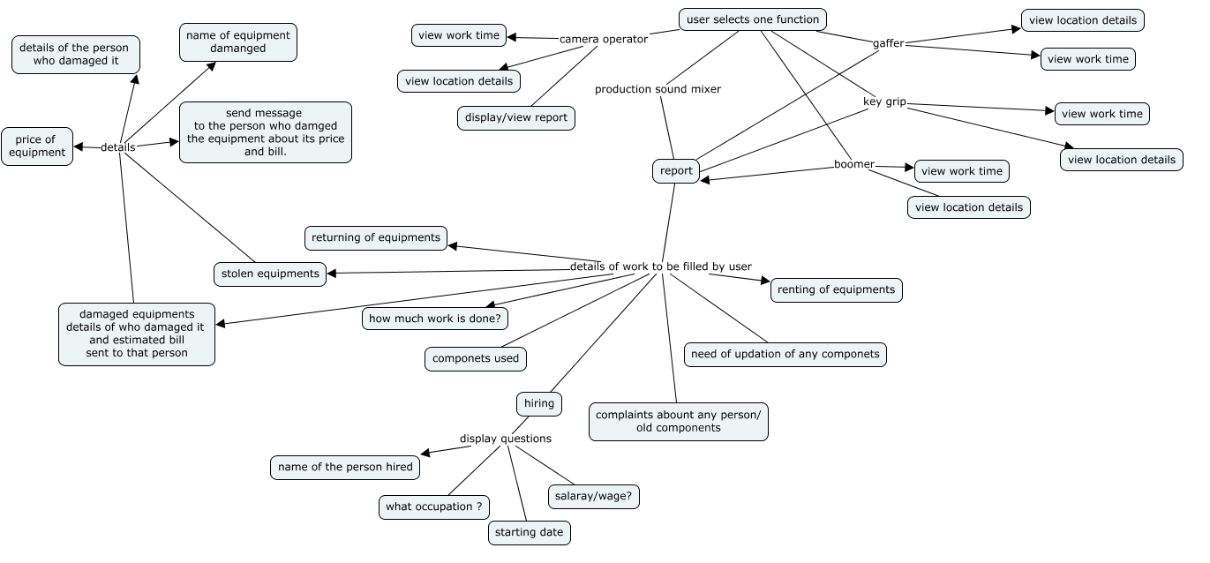

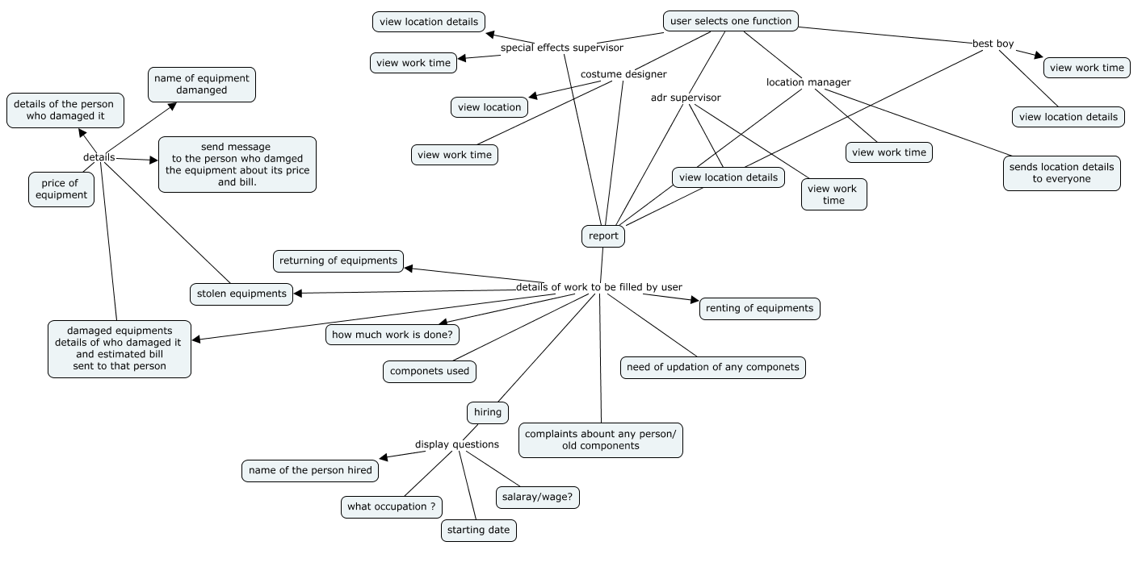

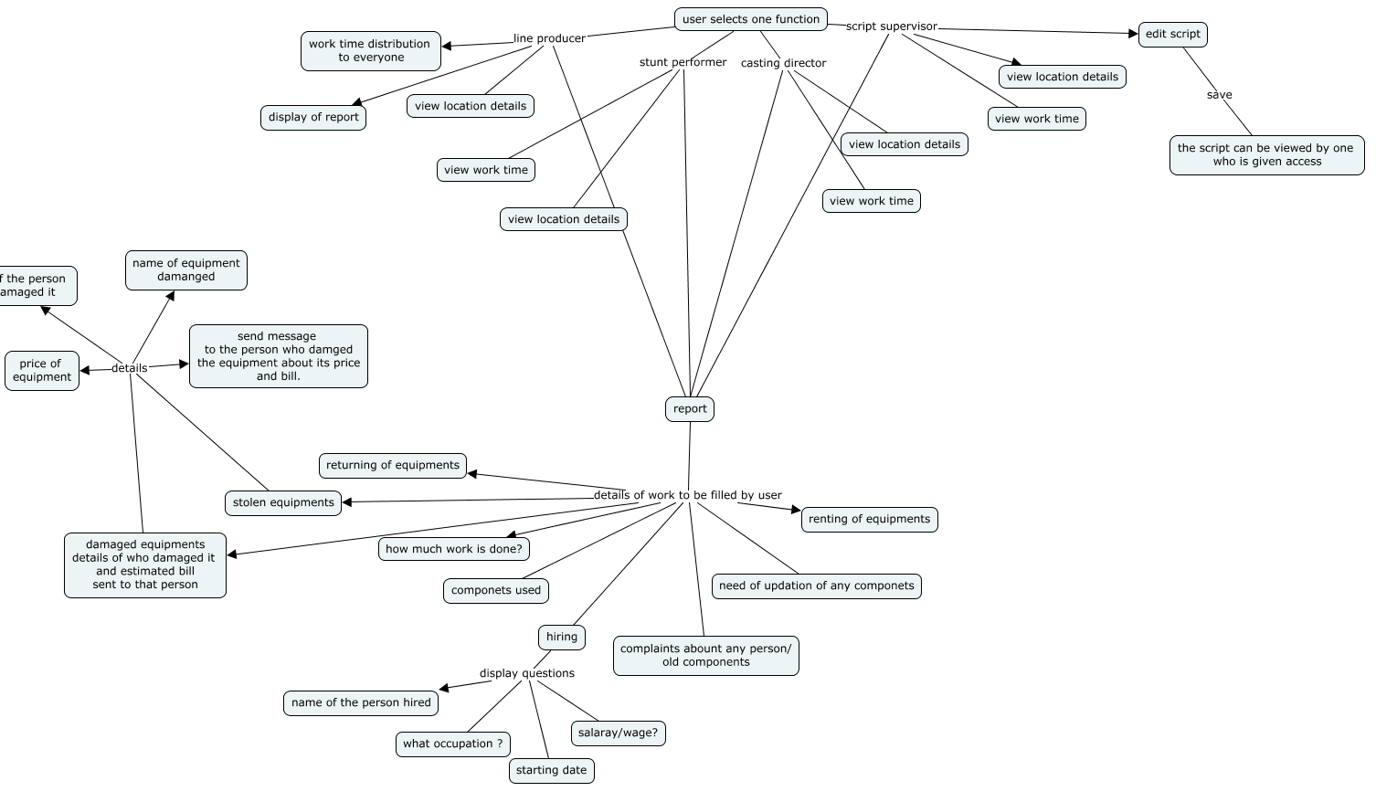

Stakeholders:

1) director

2)producer

3)actor

4)spot boy

5)makeup artist

6)executive producer

7)production assistant

8)line producer

9)location manager

10)camera operator

11)production sound mixer

12)boom operator

13)key grip

14)gaffer

15)special effects supervisor

//16)music supervisor

17)art director

//18)production designer

19)props master and analyst

20)hairdresser

21)costume designer

22)script supervisor

23)assistant director

24)adr supervisor - This person is responsible for re-recording dialogue in post-production

25)stunt performer

26)best boy - hires and manages crew

27)runner - “chotu”

28)casting director

29)editor

30)composer

31)singer

32)choregrapher

//health care for all stakeholders

//chatting feature

Director :

Director :

sab dekhtay

Saare stakeholders (most of em) end me director ko connect karte hai.

work time

location details

display of additional equipments required

display of lighting plan

report of special effects

status/report of hiring, scheduling, and management of crew;

the renting, ordering, inventory, and returning of equipment;

workplace safety and maintaining discipline within their department by best boi.

report by casting director.

display of editing process by editor

status report by singer/choregrapher/composer

Producer :

script

coordinating writing

editing

arranging financing

hire the director and other key crew members

marketing and distribution.

location details

display of additional equipments required

display of lighting plan

report of special effects

status/report of hiring, scheduling, and management of crew;

the renting, ordering, inventory, and returning of equipment;

workplace safety and maintaining discipline within their department by best boi.

report by casting director.

display of editing process by editor

status report by singer/choregrapher/composer

executive producer :

principal of all producers

finance

business

editing

location details

display of additional equipments required

display of lighting plan

report of special effects

status/report of hiring, scheduling, and management of crew;

the renting, ordering, inventory, and returning of equipment;

workplace safety and maintaining discipline within their department by best boi.

report by casting director.

display of editing process by editor

status report by singer/choregrapher/composer

line producer :

hr

handles any problems

day-to-day operations

allotes work time to all

location details

report of special effects

display of additional equipments required

display of lighting plan

display of editing process by editor

status report by singer/choregrapher/composer

actor :

accept/reject script

work time

todays script

location details

spot boi :

makeup artist :

work time

actor's details

location details

location manager :

send location details to everybody

camera operator :

work time

location details

display of additional equipments required

display of lighting plan

production sound mixer :

work time

location details

hiring boom operator

discussing problems

boom operator :

work time

location details

key grip :

work time

location details

determine additional camera equipments required

report the above to camera operator

gaffer :

work time

location details

status of lighting plan

special effects supervisor :

work time

location details

status of special effects

art director :

work time

location details

art director is to movies what software deigners are for softwares

props master and analyst :

work time

location details

report of day's work

hair dresser :

work time

location details

costume designer:

work time

location details

script supervisor :

work time

location details

editor's note

report

script editing , due to actors during actual shooting

assistant director :

work time

location details

chota mota sab dekhtay

adr supervisor :

work time

location details

status/report

stunt performer :

work time

location details

best boi :

status/report of hiring, scheduling, and management of crew;

the renting, ordering, inventory, and returning of equipment;

workplace safety and maintaining discipline within their department;

work time

location details

chotu :

work time

location details

casting director :

work time

location details

status of hiring of crew.

editor :

work time

location details

status of editing process

composer/singer/choregrapher :

work time

location details

status report